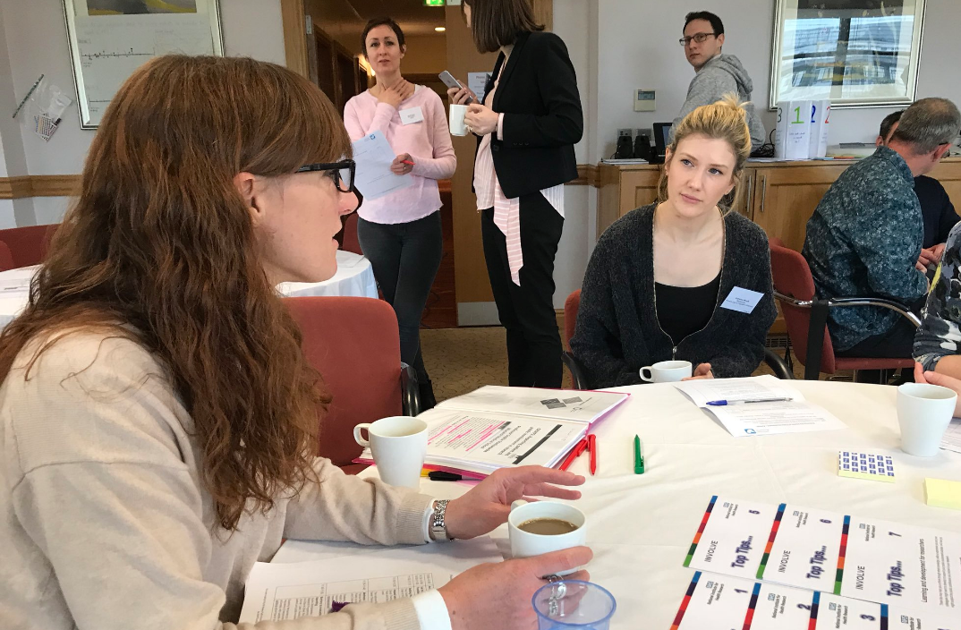
In March we (the Wessex Public Involvement Network - #WessexPIN) organised an ‘Exploring the Impact of Public Involvement’ workshop. Caroline, the PPI Officer for Research, shares her thoughts on the day and their upcoming Tweetchat.
The importance of the topic
Involving patients and the public in the research process has become part of the research culture. As a PPI facilitator, there is no doubt in mind that PPI can make a positive difference to research. I would like to ensure the PPI activities I support have the maximum impact, but to do this I need to understand what works best, for whom, and in what circumstances
The workshop
Our speakers had the huge challenge of introducing us to impact and giving us insights into how we can monitor impact. There was a general agreement that while impact means different things to different people, impact always means a change in the real world. We also heard how poor quality of PPI reporting weakens the PPI evidence base, and I am certainly interested in learning how researchers within my own organisation report on PPI.
In the afternoon we had a workshop where we explored some questions which will be discussed in more detail as part of our Wessex PIN tweetchat (Mon 23rd April, 8pm #PPIimpact). We hope this event will widen the conversation to include more groups from across the UK, and maybe even further afield! Why not join us?
Reflections
The next steps will be to really focus on generating some meaningful actions to start demonstrating impact, both in my own organisations and in the activities of the Wessex PIN. I will certainly be using Sarah Thomas’ advice to have a clear purpose to our impact work and to recognise that we are unlikely to ‘measure’ impact but we can look for indicators and evidence. My first step will be to host a meeting with our organisations public contributors to discuss some of the learnings from the day and to generate some actions for the next 6 months. So, watch this space!

