Aria – discontinuing a regimen
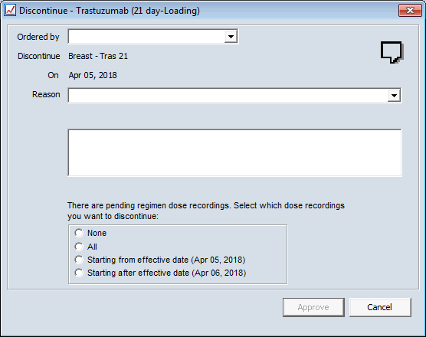
Pending Dose Recordings when discontinuing regimens.
- None
  - Indicates that none of the pending dose recordings will be discontinued and are listed for recording.
  - The regimen is discontinued, but any approved orders, will remain active until dose administration is completed.
- All
  - Indicates that all of the pending dose recordings will be discontinued
  - All Approved orders with pending dose recordings are inactivated.

- Starting from effective date (<effective date>)
  - Indicates that all of the pending dose recordings with administration dates that fall on or after the effective date will be discontinued.
  - All of the pending dose recordings that have administration dates that fall before the effective date are listed for recording.

- Starting after the effective date (<next day's date)
  - Indicates that all of the pending dose recordings with administration dates that fall after the effective date will be discontinued.
  - All of the pending dose recordings that have administration dates that fall before and on the effective date are listed for recording.

