Aria – adding an agent to patient not on a regimen (Sept 2016)

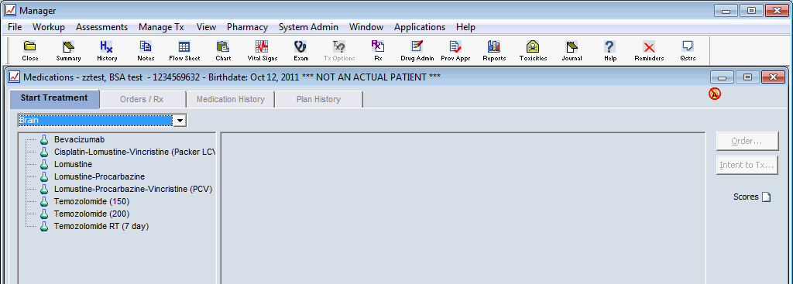
If you wish to prescribe an agent(s) for a patient who is not on a regimen click Orders/Rx tab
Click New and the usual window will open
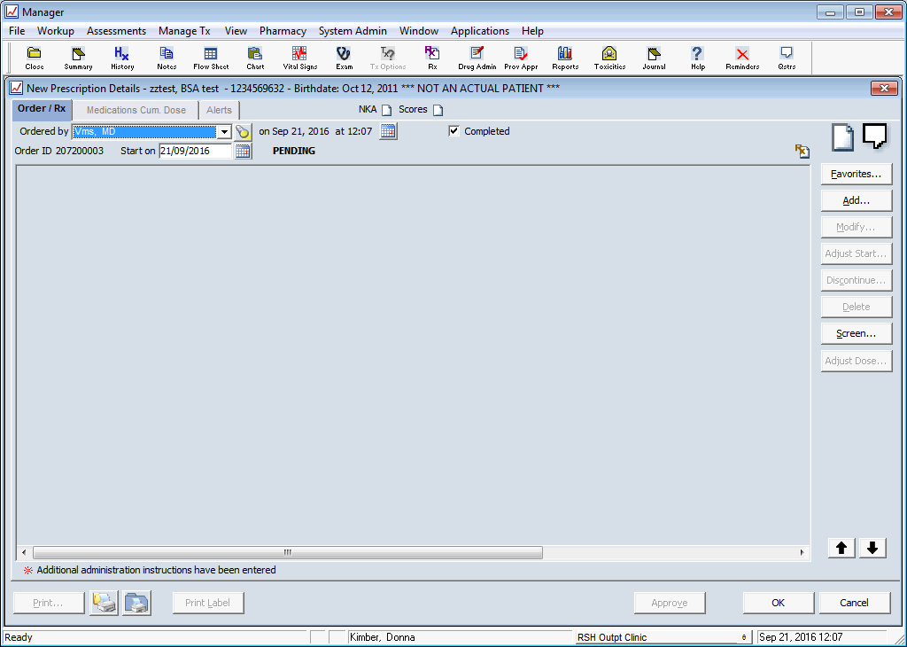
Click Favourites and select from the usual drop down menu
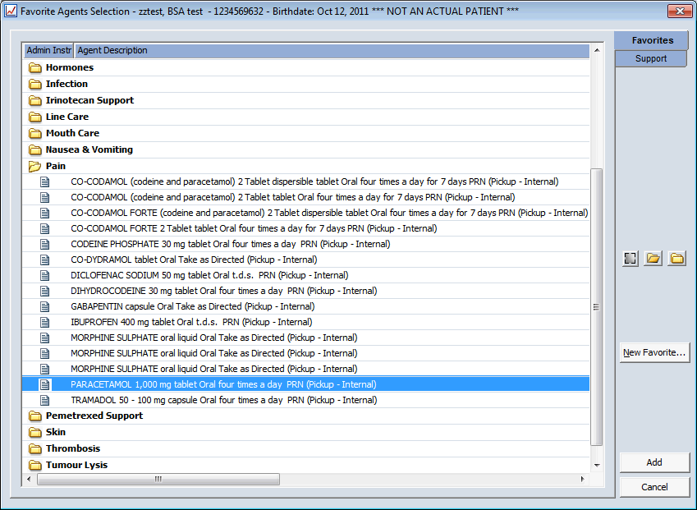
Add and Approve in the usual way
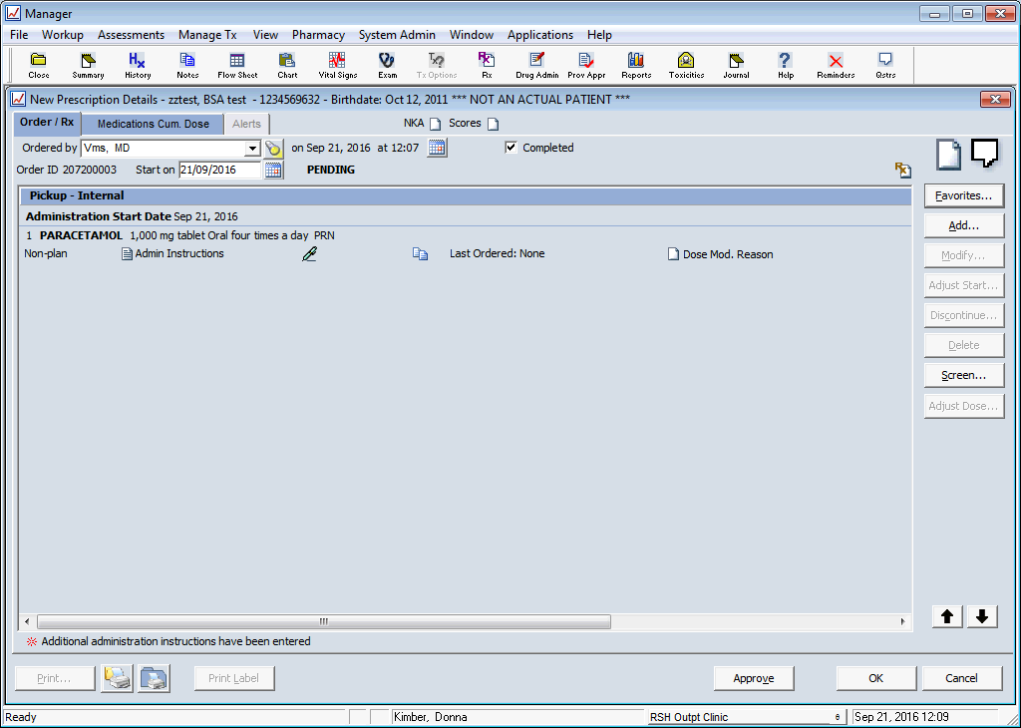
The treatment window will not show any regimen but agents it will appear in Orders/Rx

