Adding diagnosis in Patient EXAM window

Open the patient, from Open Patient window, you can change the Proceed To to Exam and then Exam window will open or select Exam icon from the tool bar, the following window will open.

NB if you add Diagnosis/Problems via the History window you will not see the prompt for Performance Status, therefore it is recommended that you always use the Exam window when entering a diagnosis.

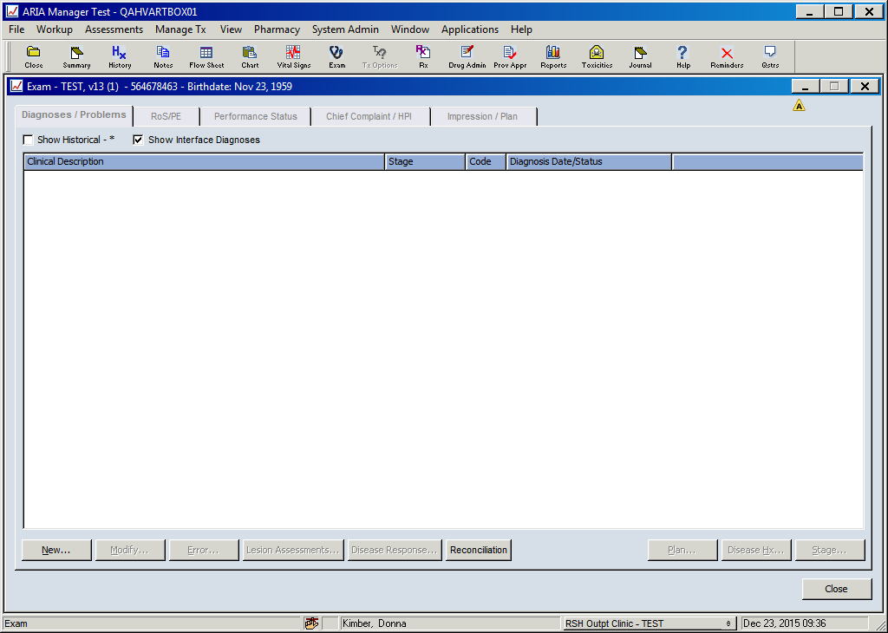

Click New.., the following window opens

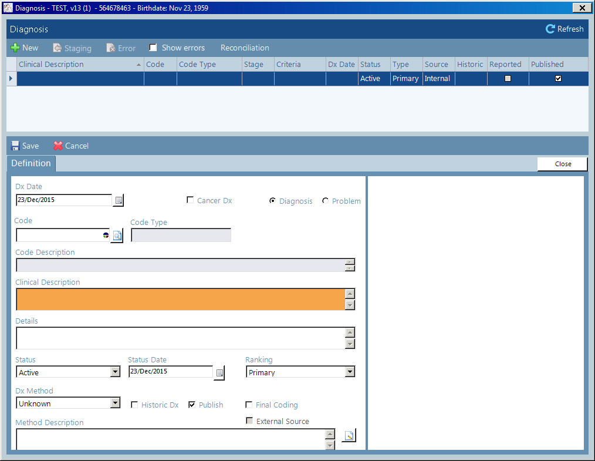

In the Code section, click the magnifying glass on the right and the following window opens

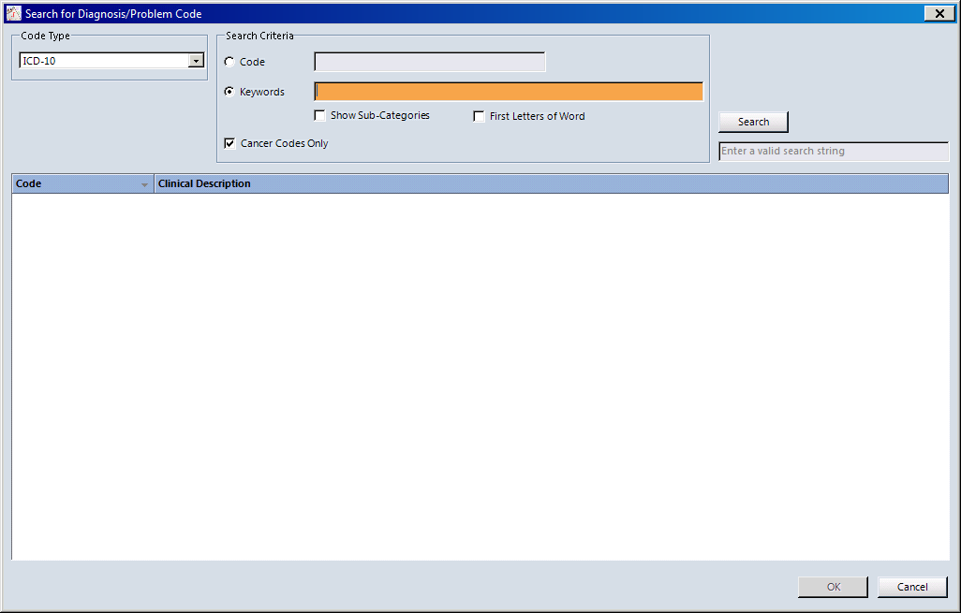

This code type is ICD-10. In the search criteria select either Code or Key words, by selecting Keywords and typing lung the following appears

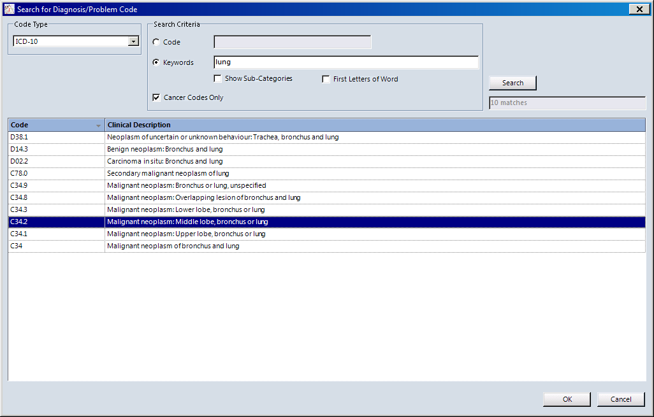

Select the correct Clinical Description eg C34.2 Malignant neoplasm of bronchus or lung, unspecified and the following appears

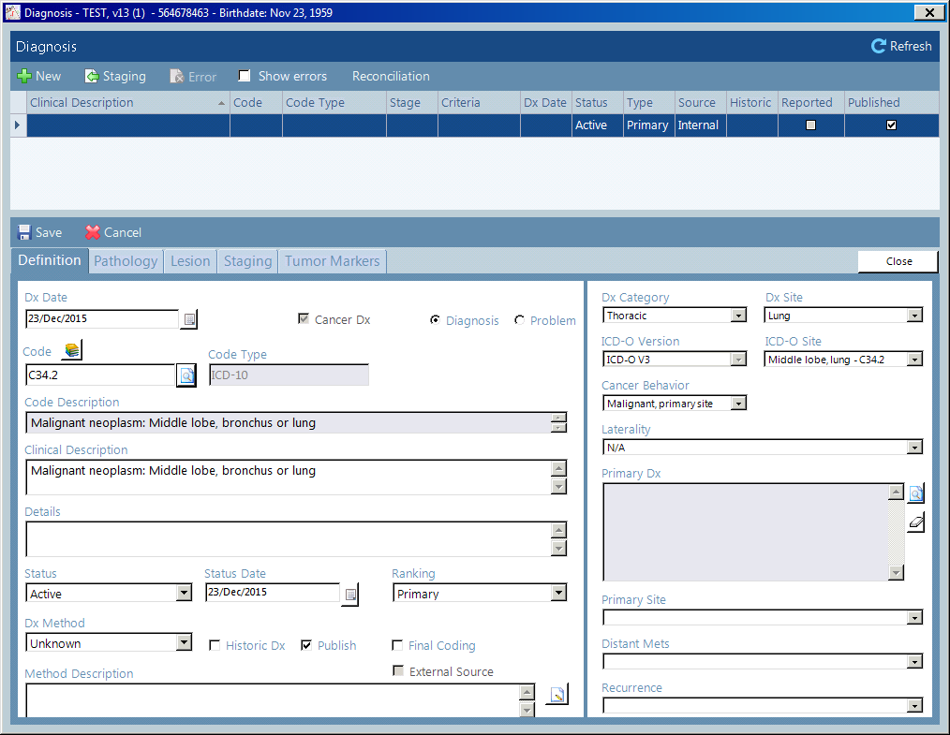

The Definition page has now opened, and any of the white boxes can now be updated.

There are also four other “tabs” now available
- Pathology – includes Cell Histology which is required to populate morphology in the SACT report
- Lesions
- Staging – required for SACT report
- Tumour Markers

Pathology – following window opens

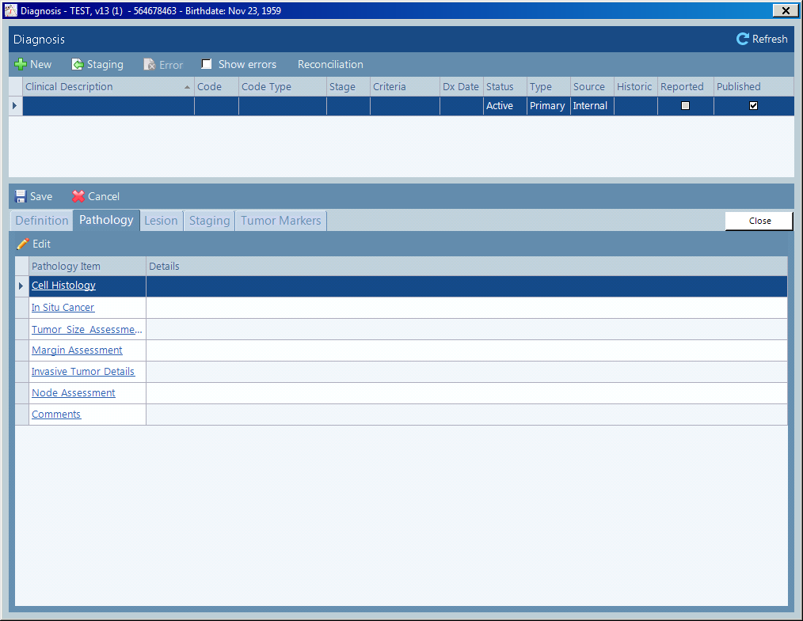

Pathology Item Select Cell History (morphology for SACT) – following window opens to be updated

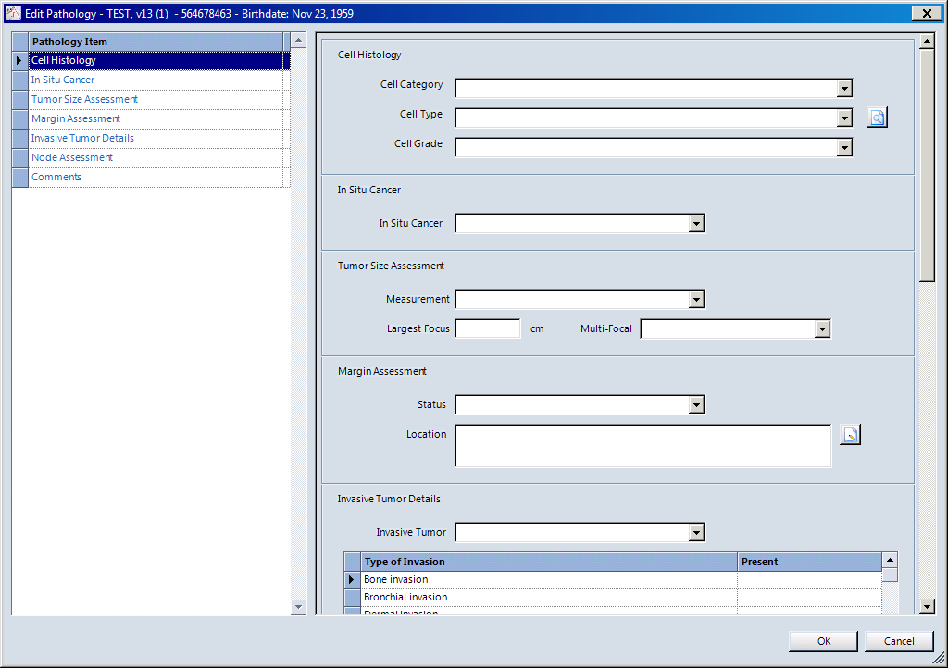

Cell Category – drop down menu
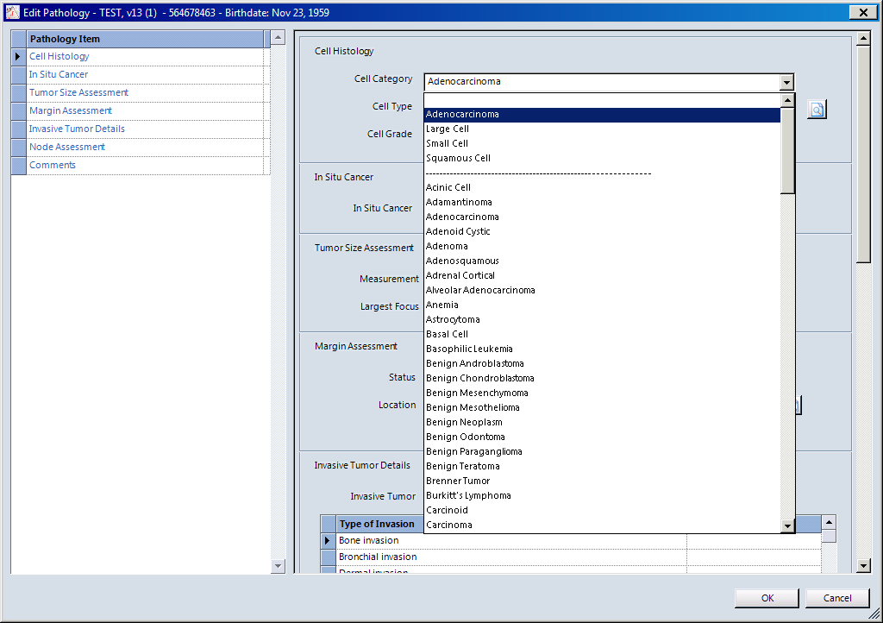

Cell Type drop down will populate once cell category has been selected
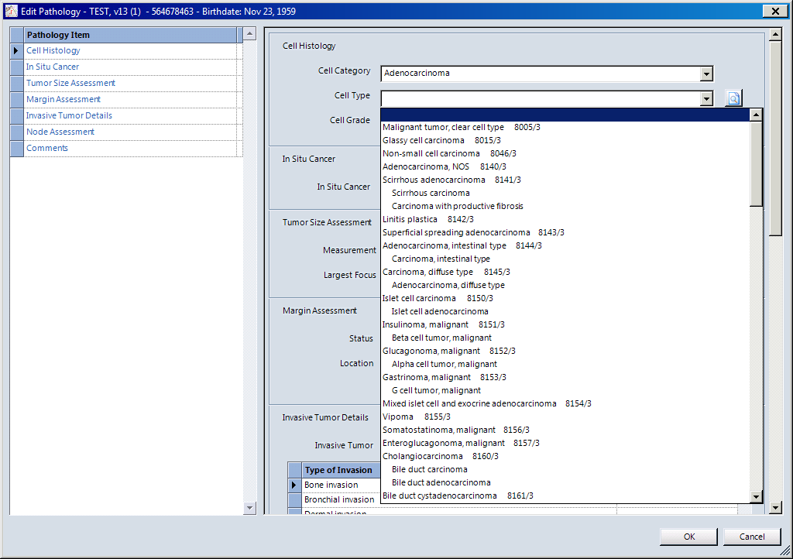

Cell Grade drop down

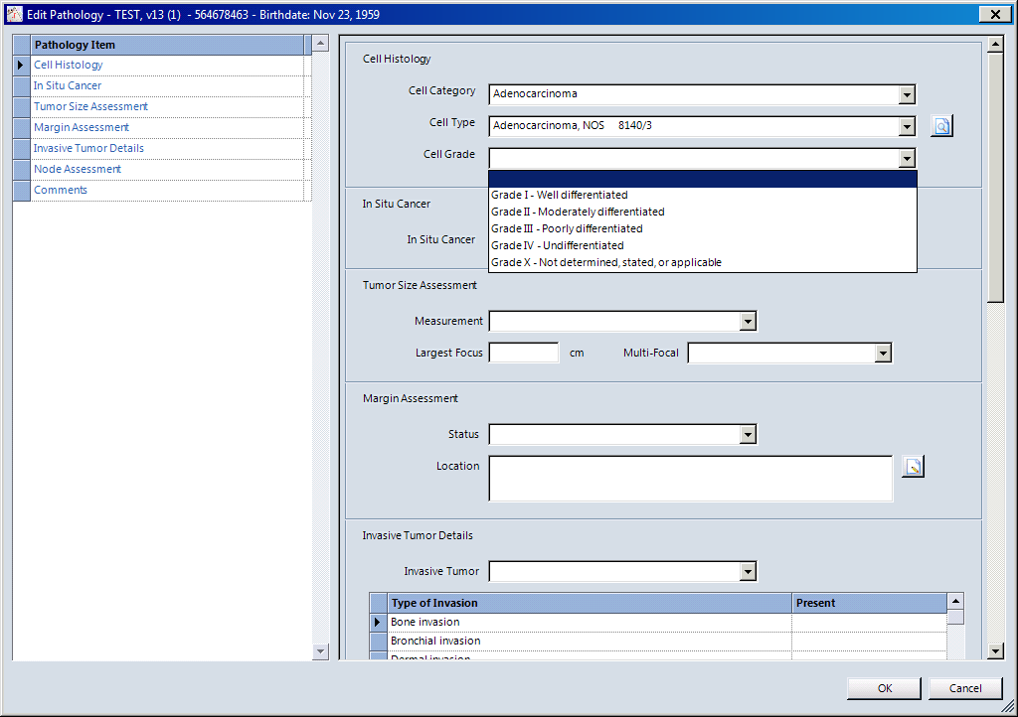

Lesions – open the following window

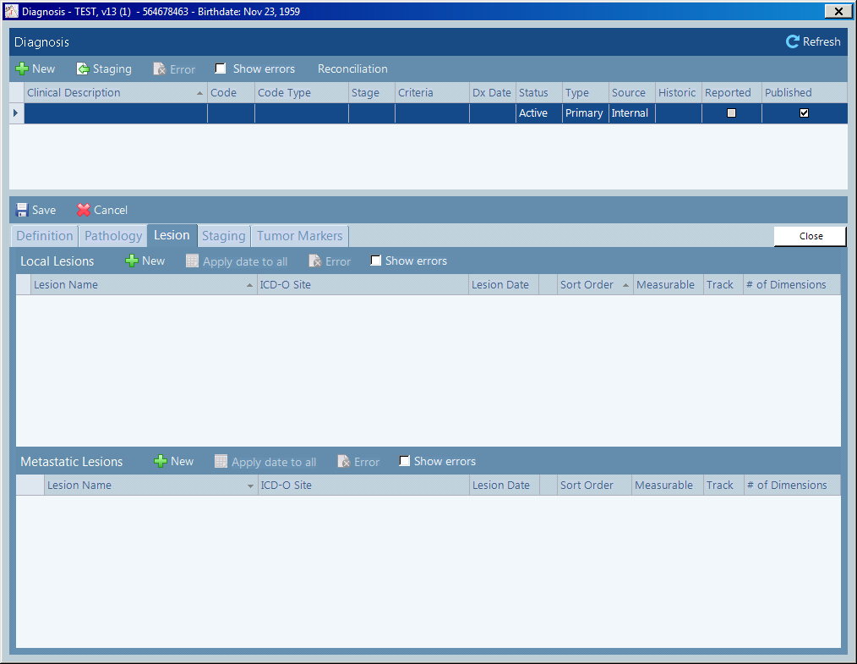

Click New in either Local Lesions or Metastatic Lesions and the following window opens

Local –

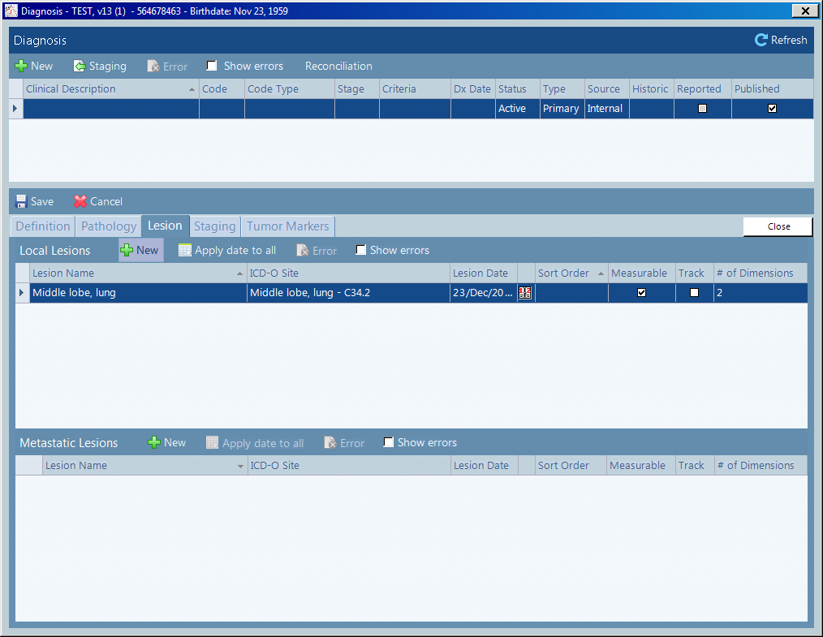

Metastatic –

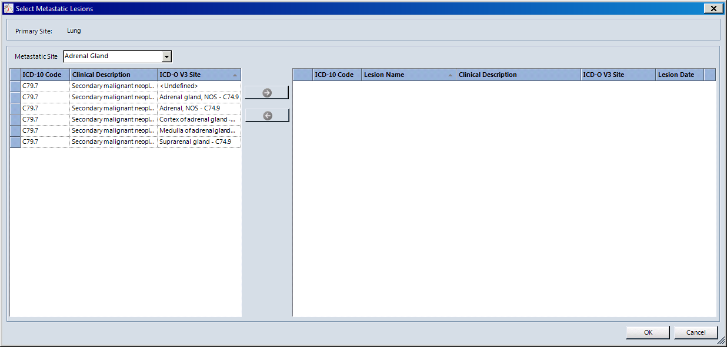

Staging – opens the following window

Click New (left of screen). The Criteria to be completed may be different depending on the disease site and scheme selected. An entry needs to be made for all criteria listed, if they are not all completed the stage will be listed as Stage X.

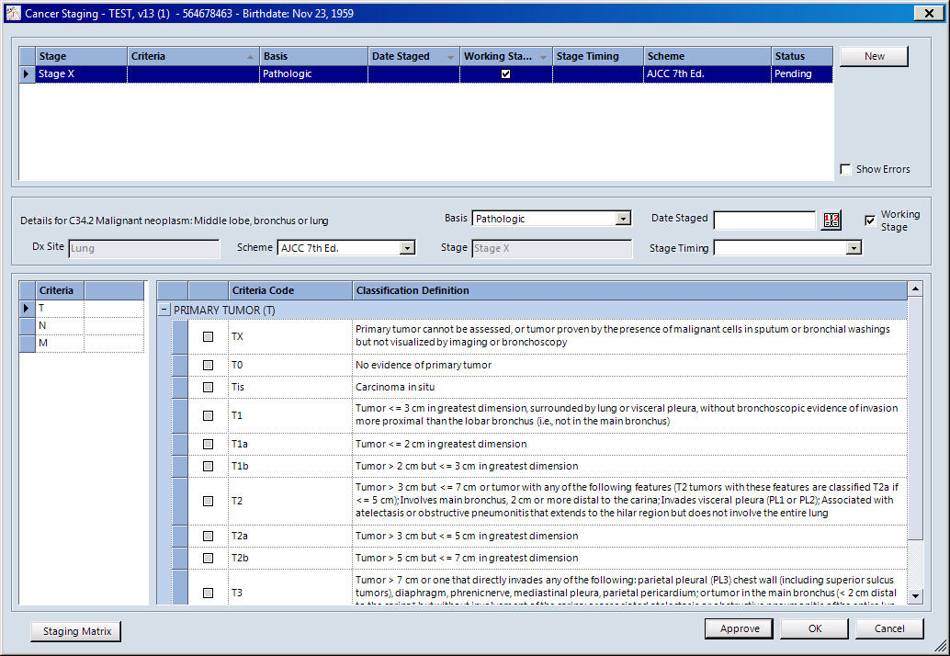

Select Tumour eg T1 and add a date into the Date Staged box

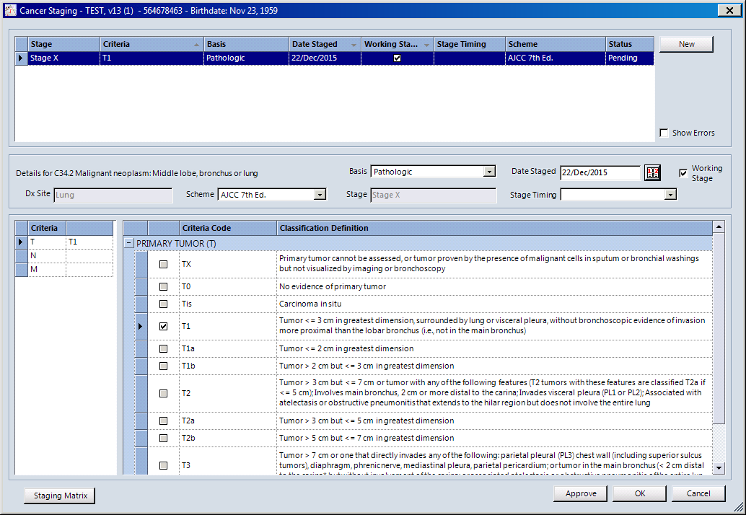

To get a complete staging also enter assessments for both nodes and metastasis; ensure a date is entered into the Date Staged box.

Nodes

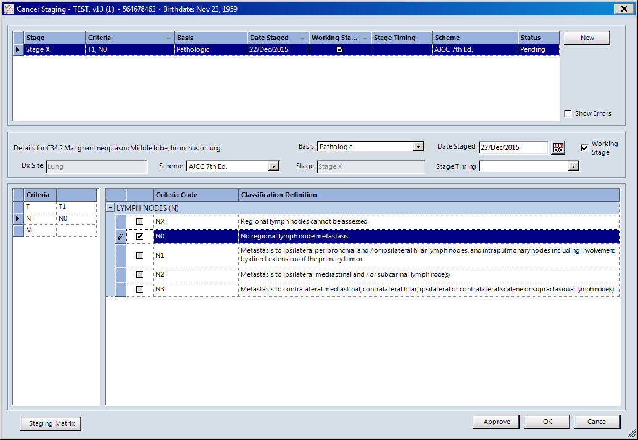

Metastasis

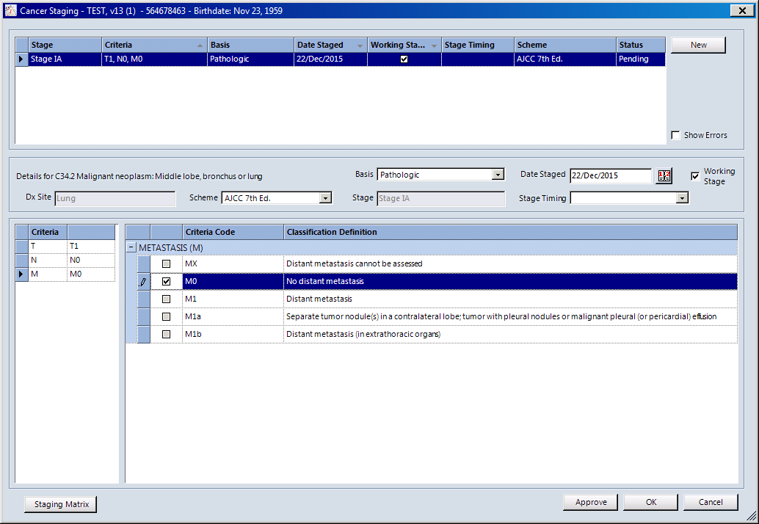

Click Approve and the information now appears as follows

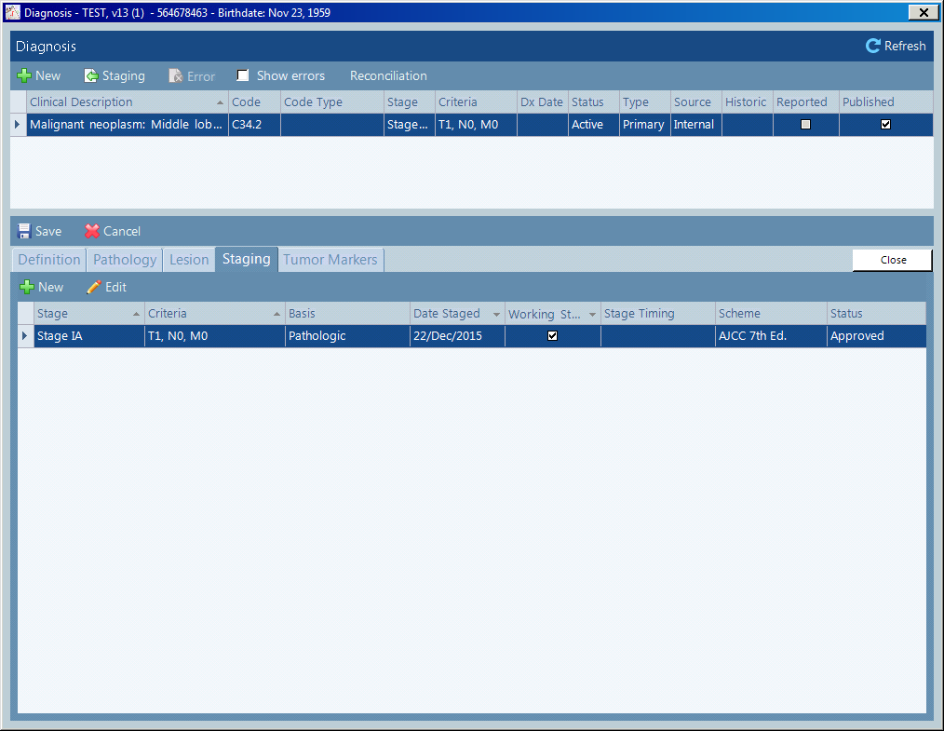

Click Save (left of screen). If you click Close you will be asked it you want to save changes as well.

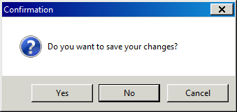

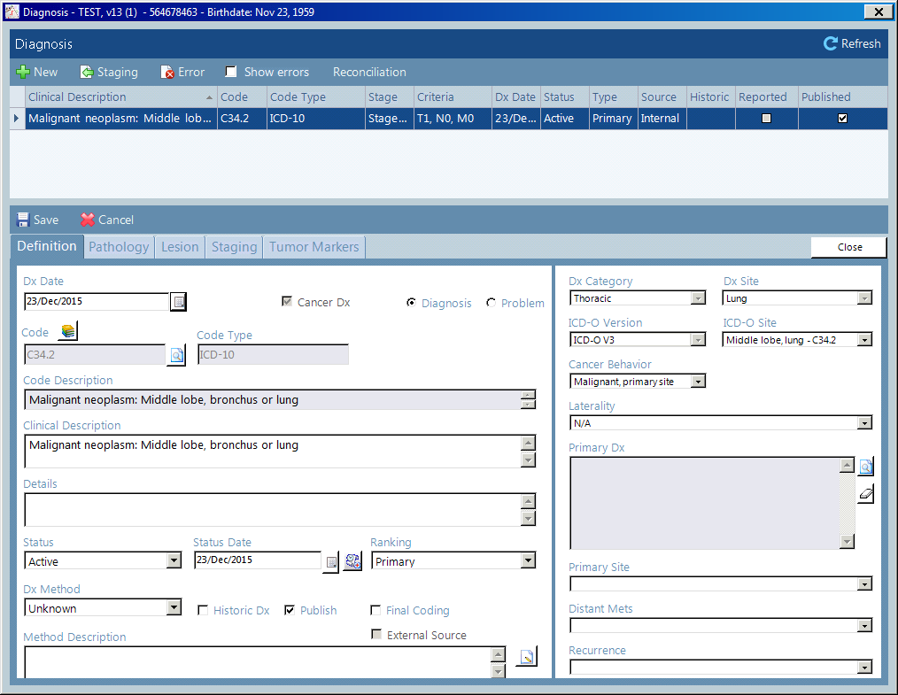

Click Close (right of screen) and the information appears on the Diagnosis / Problems window

