APPENDIX 3

How to switch between AUC doses calculated using CrCl versus EDTA.

If a regimen is defined to calculate Carboplatin using the Est Cr Cl – AUC (CrCl), the drug calculation can be switched on a patient and dose basis at the time of ordering.

Step 1

Select the day(s) of treatment and order as usual to have the doses calculated.

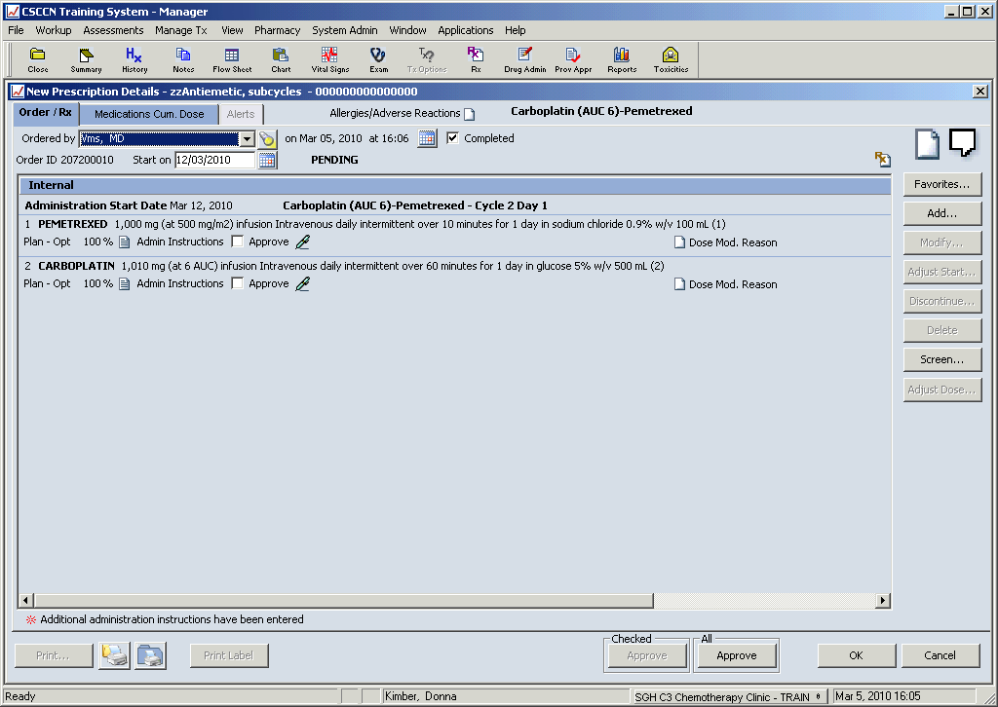

Step 2

Select the carboplatin and modify

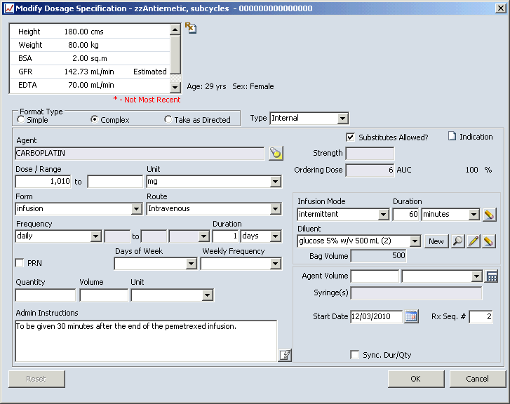

Step 3

Change the unit from mg to AUC (EDTA). You will have the option to enter an EDTA result if one does not already exist for the patient

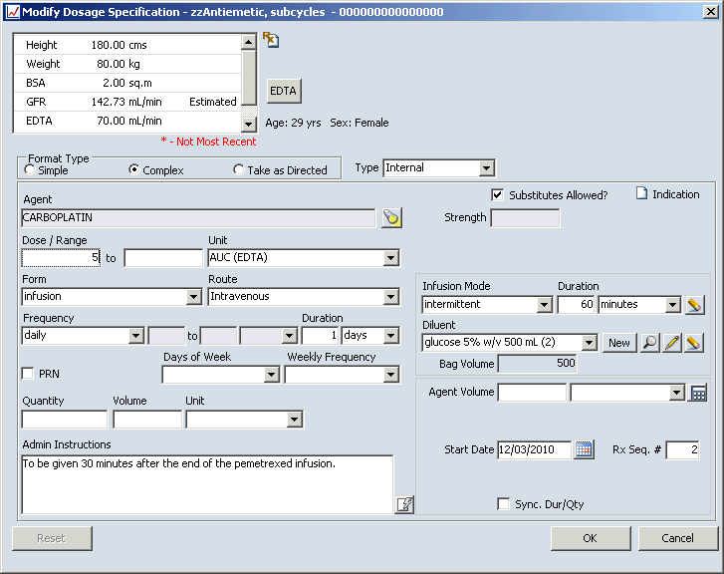

Change the Dose/Range to the desired AUC value eg 5

Step 4

If there isn’t an EDTA value, you will get a message indicating an EDTA value is absent. If there is a non-expired EDTA value, you will get a message indicating the recalculated dose.

The EDTA based AUC calculation will carry forward to the subsequent cycles until changed back.

