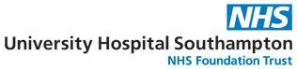

Workforce Disability
Equality Standard
-
Annual Report 2022

Executive Summary
The Workforce Disability Equality Standard (WDES) is a set of ten metrics that will help NHS organisations to compare the experiences of disabled and non-disabled staff. These metrics are necessary because evidence and research shows that the level of reported discrimination and inequality for disabled people working in the NHs remains high.
The WDES was commissioned by the Equality and Diversity Council (EDC), and developed through extensive engagement with Trusts and key stakeholders. It is mandated through the NHS Standard Contract.
Implementation of the WDES became an obligatory requirement for national healthcare organisations in 2019, so this is the fourth reporting year for the WDES metric.
It is important to note that the data sources for the WDES metrics are a combination of the 2021 National Staff Survey, and workforce data reported at the national data collection cut-off date of 31 March 2022. An infographic offering a visual comparator of WDES 2021 to 2022 has been produced, alongside a guide to the metrics (appendix 1). All NHS organisations are required to produce an action plan to articulate the response to the WDES results, this can be found within the appendices (appendix 2).

As UHS continues to develop our Equality, Diversity and Inclusion Strategy 2023-2026, we have incorporated the WDES actions contained in this report into the work programme that will deliver the strategy.

The key findings from the 2022 submission show:
- Out of a total of 13,389 staff (31 March 2022), disabled staff represent 12.16% of the workforce. Overall, this is a 1.24% decrease from 2021 data, this is not representative of wider society which 1 in 5 (22%). Further analysis shows there has been a minimal increase in representation of disabled staff within cluster 2 (AfC Bands 5-7) and 4 (AfC Band 8C-9 and VSM) of our non-clinical workforce and an increase in cluster 4 of our clinical workforce.
- Data suggests that disabled shortlisted applicants are 0.90 times likely than non-disabled applicants to be appointed to a vacant post. This is an improvement in comparison to last year and suggests that people with disabilities are more likely to be appointed than those without disabilities or long term illness. A score of 1 indicates equal opportunity and anything under 1 indicates more likely, over 1 is less likely.
- Data indicates disabled staff are less likely than non-disabled staff to be entered into a formal capability process.
- Disabled staff are more likely than non-disabled staff to experience bullying, harassment and abuse from patients, service users, relatives, members of the public, managers and colleagues than non-disabled counterparts.
- Disabled staff are less inclined to believe the Trust provides equal opportunities for career development as compared to those staff without disabilities.
- Disabled staff feel more pressure than non-disabled staff to come to work when unwell.
- Disabled staff are less satisfied than non-disabled staff that the Trust values their work.
- There has been a decrease in Disabled staff saying that UHS have made adequate adjustments for them to carry out their work.
- The staff engagement score for disabled and non-disabled staff is on par with each other and with that of overall staff engagement at UHS.
- There continues to be no declared representation of disabled staff on the Trust Board.

Other than one indicator (an improvement in the likelihood of disabled applicants being appointed from shortlisting in comparison to non-Disabled applicants), there has been minimal change. However, the disparity gap has widened in some areas as the experiences of non-disabled staff has improved. With this in mind, we are committed in continuing to have meaningful engagement with our disabled staff to co-create short and long-term actions with the support of the Long-term Illness and Disability Network to help move the Trust towards disability equality.

The WDES data 2022 confirms that the priorities in our draft EDI Strategy are the right ones, to improve or eliminate disparity between experiences of people with long term illness, and disability and those without. We must maintain our focus on:
- Inclusive recruitment practices and equal opportunities: Large scale review of current recruitment practices to eliminate bias from the systems and promote inclusivity. The Inclusive Recruitment Programme will ensure that recruiting managers are trained in inclusive recruitment techniques and criterion based methods will ensure bias is removed. We will align with the national programme for overhauling recruitment and promotion and contribute to this work wherever possible. The implementation and embedding of processes that ensure inclusive recruitment and equal opportunities for all. Our talent management programme will provide further opportunities for people with disabilities and long term illness to access development.

- Workforce reflecting our wider communities: In line with the Inclusive Recruitment programme, we will be increasing efforts to make recruitment processes inclusive and therefore not post any barriers to the community in terms of applying for roles at UHS. We will be working with specialist partners to help us to self-assess our environments for people with disabilities or long term illness. Our recruitment outreach will also work more with local communities to attract people from the city from diverse backgrounds. We will provide career toolkits for all people who are unsuccessful at interviews to help them to succeed next time. We will be continuing to promote declarations to ensure we can measure our representation across our workforce and consider a target for % of people with disabilities and long term illness in our workforce which is in line with the reported demographic of our communities.
- Safe and healthy working environments: Our Equality, Diversity and Inclusion strategy states a clear intent for UHS to become an anti-racist and anti-discriminatory organisation. We aim to decrease disparity of experience by 5% across all indicators in the WDES which will either reduce by half or eliminate disparity altogether. We will be working closer with colleague who lead on hate crime, violence and aggression to ensure robust mechanisms for reporting of incidence and the data is used to steer accountability and meaningful action. We will identify mechanisms and root causes of the disproportionality of staff with disabilities or long term illness experiencing discrimination, harassment, bullying and/or abuse and in turn whether there are trends within the trust that need targeted action. The link to the leadership and management work programme is a critical enabler of creating safe and healthy work environments. Improve the day-to-day experience of working at the Trust for disabled staff, ensuring their experience is free from discrimination, bullying, harassment and/or abuse and individuals feel they are valued.
- Inclusive leadership and management: Ensure leaders and managers are clear on their accountabilities with regards supporting people with disability and long term illness and the responsibilities they hold to deliver the actions within the EDI strategy. To have development opportunities in supporting disabled staff and those who may identify with a protected characteristic. That all leaders and managers understand their own bias and can access learning in terms of how they behave, lead and make decisions. To support leaders and managers to understand their role as allies and role models, and how to challenge behaviours or actions that are not in line with Trust policy or values. To support leader and managers to develop greater awareness of the legal aspects of their roles in relation to equality, and how diversity and difference can enhance their team delivery and performance. Ensure leaders and managers have learning development opportunities to support individuals with Disabilities and know their responsibilities in relation to the inclusion agenda and specifically actions required to ensure people with disabilities feel valued in the wider workforce.

WDES Data Return 2022

Metric 1: Percentage of staff in AfC pay bands or medical and dental subgroups and very senior managers (including Executive Board members) compared with the percentage of staff in the overall workforce.

Owing largely to a successful risk assessment campaign throughout the Covid-19 pandemic, disclosure rates in 2020 (15%) and 2021 )13.4%) accurately reflected the local population. However, recent data shows a steady yet continual decrease in declaration rates in terms of the overall representation of disabled staff within the UHS workforce. There is a slight exception of minimal increases in cluster 2 and cluster 4 of 1.3% and 0.09% respectively.

Data in Fig 1 and Fig 2 below show the total non-clinical and clinical workforce declaring a disability vs total non-disabled staff in each pay cluster as of 31 March 2022.

Fig. 1 Non-Clinical workforce presentation
 | 2021 |  |  |  | 2022
Pay clusters:
Non-clinical | Total staff in pay cluster | Total disabled staff | Total non- disabled staff | Total unknown staff | Total staff in pay cluster | Total disabled staff | Total non- disabled staff | Total unknown staff
Cluster 1
Bands 1-4 | 2008 | 14%  (283) | 69%  (1391) | 17%  (334) | 1916 | 13.25%  (254) | 71.13%  (1363) | 15.6%  (299)
Cluster 2
Bands 5-7 | 646 | 10%  (66) | 77% (495) | 13%  (85) | 743 | 11.30%  (84) | 78.06%  (580) | 10.63%  (79)
Cluster 3
Bands 8a-8b | 183 | 13%  (23) | 68%  (126) | 19%  (34) | 203 | 12.80%  (26) | 71.92%  (146) | 15.27%  (31)
Cluster 4
Bands 8c-9 & VSM | 93 | 3%  (3) | 75%  (70) | 22%  (20) | 97 | 3.09%  (3) | 81.44%  (79) | 15.46%  (15)

Fig 2. Clinical workforce representation
Pay clusters: Clinical | 2021 |  |  |  | 2022
 | Total staff in pay cluster | Total disabled staff | Total non- disabled staff | Total unknown staff | Total staff in pay cluster | Total disabled staff | Total non- disabled staff | Total unknown staff
Cluster 1
Bands 1-4 | 2434 | 16%  (384) | 73%  (1797) | 11%  (259) | 2409 | 15.19%  (366) | 74.63%  (1798) | 10.17%  (245)
Cluster 2
Bands 5 – 7 | 5015 | 16%  (799) | 70%  (3490) | 14%  (726) | 5246 | 13.62%  (715) | 73.38%  (3850) | 12.98%  (681)
Cluster 3
Bands 8a –b | 347 | 15%  (52) | 58%  (201) | 27%  (94) | 386 | 15.02%  (58) | 61.91%  (239) | 23.05%  (89)
Cluster 4
Bands 8C-9 & VSM | 38 | 18%  (7) | 40%  (15) | 42%  (16) | 39 | 20.51%  (8) | 51.28%  (20) | 28.20%  (11)
Cluster 5
Medical & Dental staff, consultants | 787 | 7%  (58) | 69%  (538) | 24%  (191) | 863 | 6.8%  (59) | 72.1%  (622) | 21.1%  (182)
Cluster 6
Medical & Dental staff, non-consultants career grades | 421 | 6%  (25) | 82%  (345) | 12%  (51) | 428 | 4.9%  (21) | 83.2%  (356) | 11.9%  (51)
Cluster 7
Medical & Dental staff, medical & dental trainee grades | 1027 | 4%  (43) | 93%  (955) | 3%  (29) | 1059 | 3.4%  (36) | 93.9%  (994) | 2.7%  (29)

In contrast to the 2021 data submission there is a decrease in representation of Disabled staff across clusters within the clinical workforce with the exception of cluster 4 which has seen an increase in representation from 18% to 20.51%.

Metric 2: Relative likelihood of Disabled staff compared to Non-Disabled staff being appointed from shortlisting across all posts. This refers to both external and internal posts.

The indicator below indicates that non-disabled staff are 0.90 times less likely to be appointed from shortlisting than disabled staff. This compares favourably to 2021, where the score was 1.02, a score below 1 indicates positive equal opportunity.

Relative likelihood of staff being appointed from shortlisting across all posts | 2022
 | Disabled | Non-Disabled
Number of shortlisted applicants | 608 | 6897
Number appointed from shortlisting | 234 | 2377
Relative likelihood of non-disabled staff being appointed from shortlisting compared to disabled staff | 0.90

Metric 3: Relative likelihood of Disabled staff compared to Non-Disabled staff entering the formal capability process, as measured by entry into the formal capability procedure..

In line with WDES guidance, there is no requirement to analyse the relative likelihood where there are fewer than 10 cases reported involving disabled staff.

Relative likelihood of staff entering the formal capability process, as measured by entry into a formal capability process | 2022
 | Disabled | Non-Disabled
Number of staff entering the formal capability process | 0 | 16
Relative likelihood of Disabled staff entering the formal capability process compared to non-disabled staff | 0

Metric 4: (Part A) Percentage of Disabled staff compared to Non-Disabled staff experiencing harassment, bullying or abuse from patients/service users, their relatives or other members of the public, managers and other colleagues;

(%s of total participants in staff survey related question, not % of total workforce)

Harassment, bullying or abuse from patients/service users, their relatives, or other members of the public:

2021: Disabled – 30%; Non-Disabled – 25.2%
2022: Disabled – 26.7%; Non-Disabled – 21.4%

There has been an improvement in numbers of disabled staff reporting they have experienced harassment, bullying or abuse from patients/service users, their relatives or other members of the public. This has decreased by 3.3 from 30% to 26.7%.
However, the disparity between the experience of bullying, harassment and abuse between disabled to non-disabled has increased from 4.8% to 5.3% due to the favourable improvement for non-disabled staff.

Harassment, bullying or abuse from managers:
2021: Disabled – 13.7%; Non-Disabled – 9.1%
2022: Disabled – 11.9%; Non-Disabled – 7%

The data indicates a 1.8% decrease from 13.7% to 11.9% for those with disabilities experiencing harassment, bullying or abuse by managers.
However, the disparity between disabled and non-disabled staff experiencing harassment, bullying or abuse by a manager has increased to 4.9%. This is concerning and highlights the need for interventions to eradicate such experience.

Harassment, bullying or abuse from other colleagues:
2021: Disabled – 26.7%; Non-Disabled – 16.2%
2022: Disabled – 21.6%; Non-Disabled – 13.6%

There is a 5.1% decrease from 26.7% to 21.6% in disabled staff experiencing harassment, bullying or abuse from other colleagues and a decrease of 2.6% from 16.2% to 13.6% in non-disabled staff. it remains a concern that 8% more disabled staff overall are experiencing such behaviours.

It is not acceptable that any staff member experiences harassment, bullying and abuse from colleagues. The action for improvement within the draft EDI strategy in terms of achieving an anti-discriminatory organisation and workstreams to reduce bullying, harassment, abuse, hate crime, violence and aggression.

Metric 4: (Part B) Percentage of Disabled staff compared to Non-Disabled staff saying that the last time they experienced harassment, bullying or abuse at work, they or a colleague reported it.

2021: Disabled – 49.6%; Non-Disabled – 46.9%
2022: Disabled – 47%; Non-Disabled – 48.7%

The 2022 data indicates a worsening of the likelihood of this indicator from 2021 of 2.6%. Whereas the indicator for non-disabled has improved by 2.6%.
Continued engagement with individuals and members of the UHS long-term illness and disability network is crucial to gain greater understanding of why individuals aren’t or don’t feel able to report such incidence, and collectively take action to improve.

It is also important to note that the participation in this question in the staff survey was lower than other questions, which therefore raises concerns in terms of perception of psychological safety in relation to reporting. .

Metric 5: Percentage of Disabled staff compared to Non-Disabled staff believing that the Trust provides equal opportunities for career development.

2021: Disabled – 58%; Non-Disabled – 64.5%
2022: Disabled – 60%; Non-Disabled – 63%

This indicator shows that disabled staff are now 2% more likely to think that the trust offers equal opportunities for career progression in comparison to the 2021 data collection.
However, it should be noted that Disabled staff are 3% less inclined to believe the Trust provides equal opportunities for career development as compared to those staff without disabilities.

Metric 6: Percentage of Disabled staff compared to Non-Disabled staff saying that they have felt pressure from their manager to come to work, despite not feeling well enough to perform their duties.

2021: Disabled – 33.1%; Non-Disabled – 23.6%
2022: Disabled – 26.9%; Non-Disabled – 19.9%

2021 data submission shows 26.9% of Disabled staff felt pressure to come to work despite feeling unwell, in comparison to 19.9% of non-Disabled staff. This shows a decrease for both comparators but does still evident a disparity of experience between Disabled and non-Disabled staff of 7%.

Metric 7: Percentage of Disabled staff compared to Non-Disabled staff saying that they are satisfied with the extent to which their organisation values their work.

2021: Disabled – 42.7%; Non-Disabled – 54.9%
2022: Disabled – 39.6%; Non-Disabled – 49.6%

Unfortunately, 2022 data submission shows a decrease in Disabled and non-Disabled perceptions on feeling valued by the organisation, with Disabled staff reporting 39.6% and non-Disabled staff reporting 49.6% satisfaction.
Whilst disparity has decreased this is due to both disabled and non-disabled rating lower dissatisfaction levels, the level of disparity of experience remains high.

Metric 8: Percentage of Disabled staff saying that their employer has made adequate adjustment(s) to enable them to carry out their work.

2021: 79.8%
2022: 78.9%

There has been a 0.9% decrease in staff saying that UHS have made adequate adjustments for them to carry out their work. With this decrease in experience, over the next year and for the long-term the trust will make demonstrative efforts in addressing this and will be a priority within the action plan as we look to launch a review of the reasonable adjustments process and introduce a policy and guidelines in supporting all staff through the process.

Metric 9: (Part A) The staff engagement % score for Disabled staff, compared to Non-Disabled staff and the overall engagement % score for the organisation.

2021: Disabled – 6.9%; Non-Disabled – 7.4%; UHS overall 7.3%
2022: Disabled – 6.9%; Non-Disabled – 7.3%; UHS overall 7.2%

It is reassuring to note that the staff engagement score for disabled and non-disabled staff is on par with each other and with that of overall staff engagement at UHS.

Metric 10: Board Voting by % disability

12.16% of the UHS population have declared a disability. There are no Trust Board members (voting or non-voting) who have declared a disability or long term illness.
The Trust will continue to encourage staff of all levels the importance of declaration and representation, but with particular focus within senior roles.

Conclusion and Next Steps
Given that we now have a significant dataset available to us and we continue to encourage higher rates in completion of the annual staff survey, we are now in a position to have meaningful engagement with our disabled staff and the wider workforce to co-create short and long-term actions with continued support of the Long-term Illness and Disability Network to help move the Trust towards disability equality. Furthermore, at this point it is important to highlight this data and the areas for improvement that are needed have also been crucial in the current production of the UHS Equality, Diversity and Inclusion Strategy and the outcomes we are committed in achieving over the forthcoming years.

As previously summarised the data indicates that we must maintain our focus on:
- Workforce reflecting our wider communities: Ensure that Disabled staff are able to access appropriate support in order to progress and remains inclusive of all roles at all levels.
- Inclusive recruitment practices and equal opportunities: large scale review of current recruitment practices and where necessary The implementation and embedding of processes that ensure inclusive recruitment and equal opportunities for all.
- Safe and healthy working environments: Improve the day-to-day experience of working at the Trust for disabled staff, ensuring their experience is free from discrimination, bullying, harassment and/or abuse and that individuals feel they are valued.
- Inclusive leadership and management: Ensure leaders and managers have development opportunities in supporting individuals with Disabilities. Ensuring that when additional support such as reasonable adjustments are required the request/or need is met sufficiently.

Our action plan which can be found in the appendices will continue to be reviewed in partnership with the Long-Term Illness and Disability network. The proposed actions will continue to be discussed in terms of progress at Equality, Diversity and Inclusion Council, Equality, Diversity and Inclusion Committee and People and Organisational development Committee. This analysis report along with the relevant action plan will be published on our public website by 31st October to meet the requirements set by the Workforce Disability Equality Standard (WDES).

Appendices
Appendix 1: Infographic to visualise WDES data
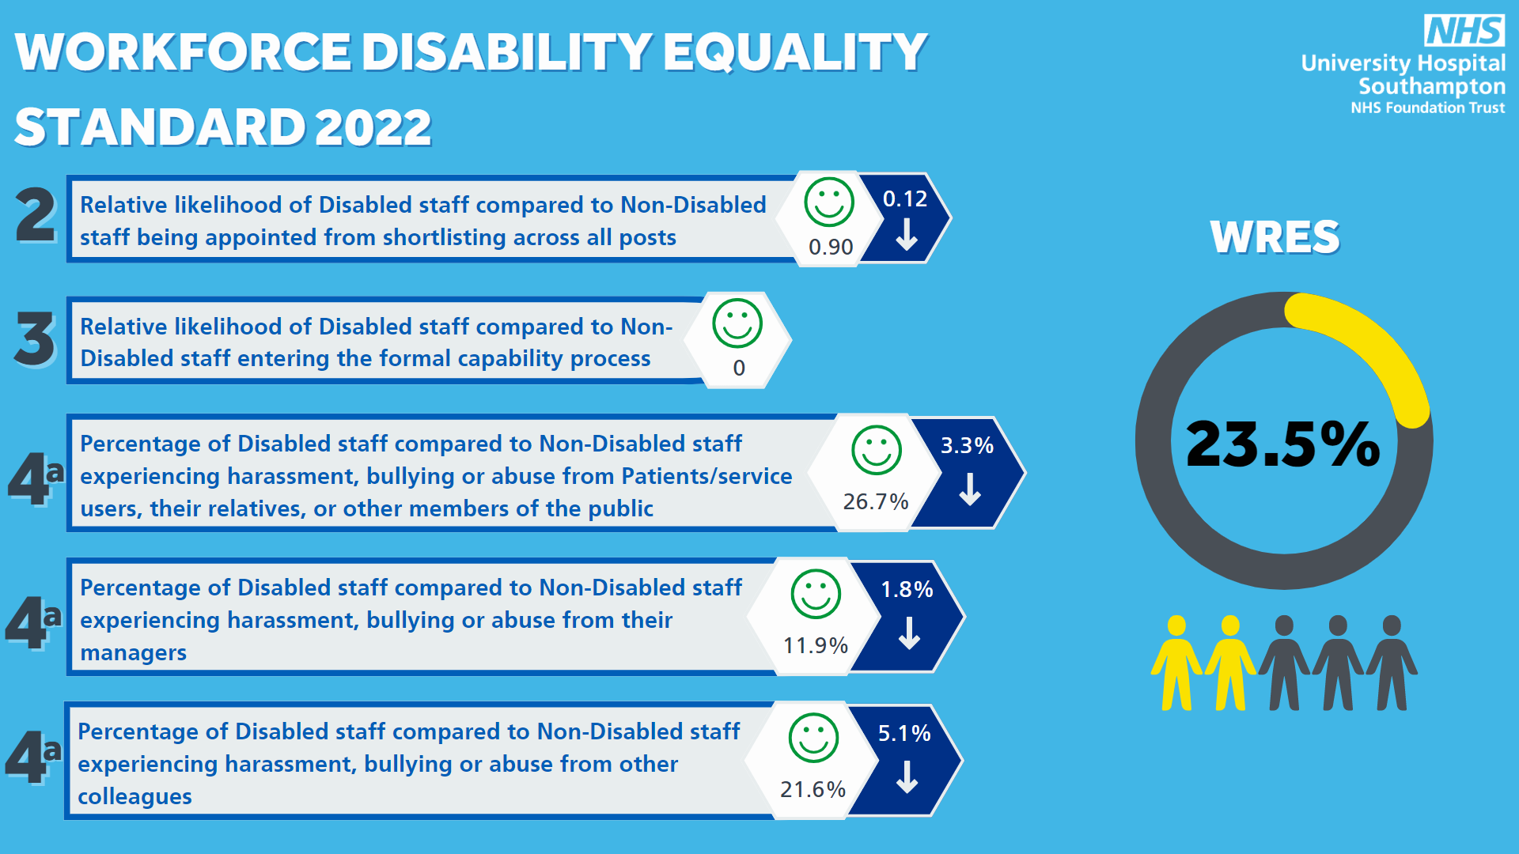
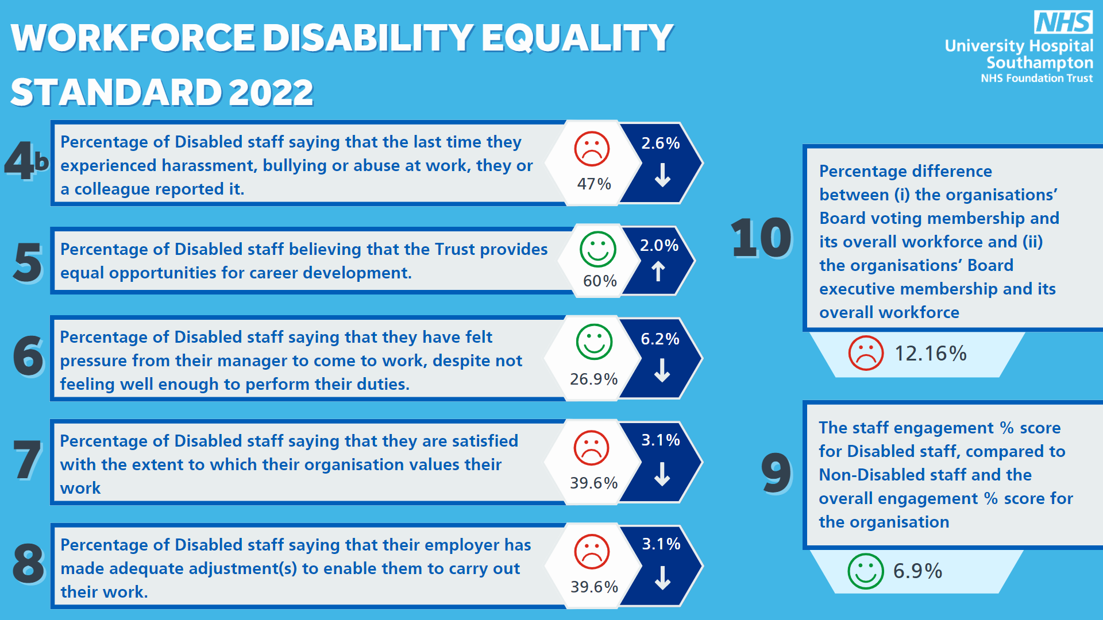
Appendix 2: WDES Action Plan 2022

WDES Themes / Areas | Proposed actions | Responsible for Actions | Deadline / review date
1: Workforce reflecting our communities, at all roles, at all levels; ensuring those who are underrepresented groups can access support to thrive, excel and belong within their roles. | - To develop and initiate positive Action Programmes both UHS and HIOW system wide; for those who have disabilities and/or long-term conditions as well as other protected characteristics. Acknowledging individuals experience of barriers to promotion, development and career progression. | Workforce Inclusion & Belonging Consultant / Head of EDI / Head of OD | July 2023
 | - UHS partnership with maaha people in developing and running a positive action leadership programme which will enrol 24 individuals who identify with a protected characteristic and will be designed to support individuals looking to move into, or those who are moving through senior leadership roles within the organisation, building on individuals personal identity, power and influence within the organisation. | Workforce Inclusion & Belonging Consultant | January 2023
 | - Partnership with the Florence Nightingale Foundation; Nurse leadership programme aimed at aspiring nurses from backgrounds that are under-represented in our nursing workforce and ensuring that opportunity for individuals who identify as disabled is equal and representative of wider society. | Deputy Director of Nursing & Head of OD | April 2023
 | - Talent development programme for individuals with a disability and/or long-term condition. Supporting the career development, pathways, training and development of individual’s, ensuring talent workstreams and pipelines that encourage opportunity at earlier stages than current and may include long-term career planning. Develop a talent pipeline/talent management plan to include stretch activities, secondments, shadowing, specialist training, qualifications, coaching and mentoring where it is anticipated a career change will be necessary. This will look at strengthening as well as unearthing our current talent within UHS and ensuring that individuals continue to thrive, excel and belong and we support them to do this. | Head of Talent Management / Head of EDI / Workforce Inclusion & Belonging Consultant | July 2023
 | - Continue to build on newly found working relationship with Southampton job centre. Continue to liaise, attend and promote UHS as an employer of choice to disabled individuals within the wider community, the support that is offered and the career opportunities that available including that of our volunteering roles. | Workforce Inclusion & Belonging Consultant / HR Recruitment team | April 2023
 | - Propose and agree a declaration target throughout the organisation for those who identify as having a disability and/or long-term condition. Representation within wider society is currently 22% and therefore a declaration and representation rate of 20% will be proposed and what we know from engagement within the staff survey (2021) is representative at UHS. To achieve this workstreams will include more in depth narrative about declaration of disability and its importance within the onboarding and induction process within UHS and will include literature on the processes of how to declare. Continue with lived experiences pieces and continue to socialise within internal and external communications methods. Continue to at every opportunity irradicate stigma surrounding what happens if an individual declares a disability and continue to showcase the support we offer to individuals within the organisation as a disability confident employer. | Director of OD & Inclusion / Chief People Officer | April 2023
2: Safe and healthy working environments, free from aggression, hate and discrimination | - Creation of a behaviour framework to bring to live our Trust Values and more clearly describe the expected behaviours relating to equality, diversity and inclusion that impact individuals with a disability and/or long-term condition. | Director of OD & Inclusion / Head of EDI / Workforce Inclusion & Belonging Consultant | August 2023
 | - Fully establish divisional EDI Steering Groups to drive actions and improvements derived from Disability specific metrics throughout all teams, care groups and divisions. | Director of OD & Inclusion / Head of EDI | April 2023
 | - Creation of EDI data and information dashboard to evidence improvements and scrutinise themes that impact individuals with a disability and determine actions required. | Director of OD & Inclusion / Head of EDI | April 2023
 | - Developing a culture of Allyship: All staff to participate in Actionable Allyship training by 2024. The actionable allyship – stop.Start.continue programme will continue on the statutory and mandatory matrix for all staff to complete. This will provide individuals with the insight, knowledge and skill and to be active allies within a moment of challenging non inclusive behaviours and supporting out statement in being a anti-discriminatory organisation and in turn decrease the disparity of experience between those who have disabilities and those who don’t. | Workforce Inclusion & Belonging Consultant | August 2023
 | - Develop a process where conversation of long-term conditions and disabilities are standard processes within 1.2.1’s, wellbeing conversations and appraisal conversations. Highlighting all individuals responsibility to show allyship and continue to support individuals throughout their work at UHS. | Head of EDI / Workforce Inclusion & Belonging Consultant | August 2023
3: Recruitment processes which free from bias and are inclusive | - Implement a work programme to review and improve the equity of recruitment processes and practices that impact individuals with a disability and/or long-term condition. Working group to include partnership with our Staff Network leads and representation from our diverse workforce. The working group will look at each stage and deliver on recommendations from engagement within the process. Aligning to the NHS People Plan England/Improvement High Impact Actions and Inclusive Recruitment Programme. | Workforce Inclusion & Belonging Consultant | December 2022
 | - Inclusive training, learning and development for all people involved in recruitment and attraction. | Head of Talent attraction / HR Recruitment Team | September 2023
 | - Deliver a truly Disability friendly process with disability inclusive practices as standard. This will include processes from pre-employment to recruitment, through to employment and the onboarding process. | Head of HR / Head of EDI / Workforce Inclusion & Belonging Consultant | September 2023
 | - Develop an inclusive employer recruitment campaign in embedding our Disability confident status and our intentions to move towards disability confident leader within the next 3years. | Head of HR / Head of EDI / Workforce Inclusion & Belonging Consultant / LID Network | September 2023
4: Inclusive leadership and management | - Inclusive Leadership content in all UHS leadership & management programmes to include personal learning, person action and accountability. This will move us to a place where equality, diversity and inclusion is the golden thread that runs through all our processes at UHS. | Head of OD / Head of Leadership & Development / Head of EDI / Workforce Inclusion & Belonging Consultant | April 2023
 | - Board and Senior leadership programmes to include the element for all leaders plus strategic and cultural responsibilities for equality, diversity and inclusion. | Head of OD / Head of EDI | July 2023
 | - Inclusive leadership and management as part of the UHS Managers Induction Programme. | Head of Leadership & Development / Head of EDI / Workforce Inclusion & Belonging Consultant | April 2023
 | - Implementation of ongoing learning and development opportunities to enable leaders and managers to role model inclusive behaviours every day. For example:  - Inclusive meetings  - Agile working  - Equality impact assessment  - Adjustments required to enable people to thrive and be at their best at work.  - Creating environments for people to succeed  - Inclusive leadership behaviours aligned to our values | Head of EDI / Workforce Inclusion & Belonging Consultant | September 2023
5: Networks and partnerships that thrive and support creation of an inclusive and safe place to work. | - Development programmes for Networks and Network Chairs clearly identifying roles to enable leadership of highly active networks, clarity of purpose and future plans. Development opportunities will include coaching, mentoring, influential leadership skills, recognising their contributions as career development. | Head of EDI / Workforce Inclusion & Belonging Consultant | May 2023
 | - Implement and establish the Equality, Diversity and Inclusion Council; A place for network leads and members alongside the equality, diversity and inclusion team to dialogue with one another, bring forward ideas or concerns from the networks and a place for the voices of all individuals within the organisation to be recognised. This will also offer a place for future projects and funding to be discussed and where a decision on what escalations/risks need to be raised within committee meetings. | Director of OD & Inclusion / Head of EDI / Workforce Inclusion & Belonging Consultant | November 2022
 | - Establish and support new staff networks, as per requested:  - Long COVID support group  - Women’s Network  - Carers Network  - Veterans Network | Head of EDI / Workforce Inclusion & Belonging Consultant | April 2023

