Workforce Race Equality Standard
-
Annual Report 2022

Table of Contents
Executive Summary 3
Introduction 5
WRES Data Submission 2022 6
Indicator 1: Percentage of staff in each AfC Band 1-9 and VSM compared to overall workforce 6
Indicator 2: Relative likelihood of BME staff being appointed from shortlisting 8
Indicator 3: Relative likelihood of staff entering a formal disciplinary process 8
Indicator 4: Relative likelihood of staff accessing non-mandatory training and CPD 9
Indicator 5: Percentage of staff experiencing harassment, bullying or abuse from patients, relatives, or the public 9
Indicator 6: Percentage of staff experiencing harassment, bullying or abuse from staff 9
Indicator 7: Percentage of staff believing that the Trust provides equal opportunities for career progression or promotion 10
Indicator 8: Percentage of staff personally experiencing discrimination at work by a manager/team leader or other colleagues 10
Indicator 9: % difference between the organisations’ Board voting membership and its overall workforce 10
Conclusion and Next Steps 11
Appendix 1: Infographic to visualise WRES data 12
Appendix 2: WRES Action Plan 2022 13

Executive Summary
The Trust has submitted WRES data since 2015 and has a quarterly programme of reviewing progress against the nine indicators contained within the WRES dashboard. This report shows the latest dataset from 2022 and explores whether there have been any significant improvements or deterioration compared with the results from 2021.
An updated WRES action plan is also within this report (Appendix 2), which shows the areas of focus for the Trust in the coming year. In addition to the analysis within the report an infographic offering a visual representation of the data is also found in Appendix 1.
The key findings from the 2022 submission show:
- BME staff represent 23.5% of the workforce, which is a 2.5% increase from the 2021 data submission. There continues to be an overall improvement in proportionate representation in most of the bands since 2021and especially so amongst the clinical workforce.
- There is no more or less likelihood that BME applicants will be appointed from shortlisting than white applicants. (Data from Trac automatic download into ESR).
- BME staff continue to be less likely than White staff to be entered into a formal disciplinary process.
- BME staff are less likely than White staff to access non-mandatory training and continued professional development opportunities.
- BME staff experience more harassment, bullying or abuse from patients, relatives or the public than white staff, with the gap of inequality continuing to widen.
- BME staff report a higher level of experiencing harassment, bullying or abuse from other staff compared with White staff.
- The perception around the equal opportunities for career progression or promotion within the Trust is lower amongst BME staff than it is for White staff.
- BME staff are more than twice as likely as White staff to report personally experiencing discrimination at work by a Manager/Team leader or other colleagues.
- The representation of BME staff on the Trust Board has increased to 14%.

It is reassuring that all nine indicators have seen an improvement from 2021, however viewing the context of the improvements in line with the disparity gap shows that there is still a large gap between the experiences of people from black and minority ethnic backgrounds and white backgrounds. This is where we must focus our efforts in order to make sustained improvements.

The action plan sets out in detail the priorities and programmes of work as part of the Trust’s Equality, Diversity and Inclusion Strategy which will drive improvements against these indicators. The action plan will continue to be reviewed by the One Voice Staff Network and reviewed by the regional NHSi EDI Lead.

The outcomes of the WRES does not alter the themes contained in our strategy, and the action plan is aligned to these themes:
- Inclusive recruitment practices and equal opportunities: Large scale review of current recruitment practices to eliminate bias from the systems and promote inclusivity. The Inclusive Recruitment Programme will ensure that recruiting managers are trained in inclusive recruitment techniques and criterion based methods will ensure bias is removed. We will align with the national programme for overhauling recruitment and promotion and contribute to this work wherever possible. The implementation and embedding of processes that ensure inclusive recruitment and equal opportunities for all. This will be in line with the National 6 high impact actions. Our talent management programme will provide further opportunities for people from BME backgrounds to access development and the review of processes for data collection in terms of training, development, recording as part of the data dashboard workstream will ensure the intelligence is available to correctly measure whether we are improving access or if there is more action required.

- Workforce reflecting our wider communities: In line with the Inclusive Recruitment programme, we will be increasing efforts to make recruitment processes inclusive and therefore not post any barriers to the community in terms of applying for roles at UHS. We will be implementing a specific project with Black History Month South which focuses on outreach to the black communities in Southampton to promote roles and careers within UHS. Our recruitment outreach will also work more with local communities to attract people from the city from diverse backgrounds. We will be implementing positive action talent programmes that will enable people from black and ethnic backgrounds to access development, networking, and coaching to confidently apply and be successful at roles when they become available. We will provide career toolkits for all people who are unsuccessful at interviews to help them to succeed next time. We will continue to strive to meet the national target of 19% representation in band 7s and above.

- Safe and healthy working environments: Our Equality, Diversity and Inclusion strategy states a clear intent for UHS to become an anti-racist and anti-discriminatory organisation. We aim to decrease disparity of experience by 5% across all indicators in the WRES which will either reduce by half or eliminate disparity altogether. We will be working closer with colleagues who lead on hate crime, violence and aggression to ensure robust mechanisms for reporting of incidence and the data is used to steer accountability and meaningful action. We will identify mechanisms and root causes of the disproportionality of BME staff experiencing discrimination, harassment, bullying and/or abuse and in turn whether there are trends within the trust that need targeted action. The link to the leadership and management work programme is a critical enabler of creating safe and healthy work environments.

- Inclusive leadership and management: Ensure leaders and managers are clear on their accountabilities with regards to EDI and the responsibilities they hold to deliver the actions within the EDI strategy. To have development opportunities in supporting BME staff and those who may identify with a protected characteristic. That all leaders and managers understand their own bias and can access learning in terms of how they lead and make decisions. To support leaders and managers to understand their role as allies and role models, and how to challenge behaviours or actions that are not in line with Trust policy or values. To support leader and managers to develop greater awareness of the legal aspects of their roles in relation to equality, and how diversity and difference can enhance their team delivery and performance.

Introduction
Research and evidence strongly suggest that less favourable treatment of black and minority ethnic (BME) staff in the NHS, through poorer experience or opportunities, has significant impact on the efficient and effective running of the NHS and adversely impacts the quality of care received by all patients. The NHS Workforce Race Equality Standard (WRES), introduced in 2015, seeks to prompt inquiry to better understand why it is that BME staff receive poorer treatment than White staff in the workplace and to facilitate the closing of these gaps.
This is the 2022 annual WRES Data report. Data has been directly compared to 2021 data providing a clear picture on the indicators where the Trust is performing well and those that require our focus in the year ahead.
Despite an improvement in the overall representation of BME staff in the workforce, the data highlights that the experiences and opportunities for BME staff are not the same as for White staff, and more action and focus is needed to close the gap in experience between these two staff groups.
The focus of this report is to present the Trust’s performance against the WRES indicators for the past 12 months and provide recommendations and an action plan by which to better our performance and ultimately improve the experience and opportunities for our BME staff in the coming years.

WRES Data Submission 2022
The WRES submission is comprised of 9 indicators which compare the experience of White and BME staff in an employment context. The submission for 2022 is broken down below and compared with data from the 2021 submission, with a summary of whether there has been an improvement or deterioration in the data. It is important at this point to note that indicators 5 to 8 are measurements taken from the 2021 staff survey and therefore are percentages of individuals who took part and not of the total workforce which is the case for indicators 1 to 4 and indicator 9, which are taken directly from the trusts electronic staff records system (ESR).

Indicator 1: Percentage of staff in each AfC Band 1-9 and VSM compared to overall workforce

Non-Clinical
Non Clinical Workforce | 2021 |  |  |  |  | 2022 |  |  |  |  | Change from 2021/22 in BE
 | White |  | BME |  | Total | White |  | BME |  | Total
 | # | % | # | % | # | # | % | # | % | #
Band 1 | 43 | 87.76% | 6 | 12.24% | 49 | 32 | 86.48% | 5 | 13.51% | 37 | +1.27%
Band 2 | 749 | 85.50% | 127 | 14.50% | 876 | 660 | 87.18% | 97 | 12.81% | 757 | -1.69%
Band 3 | 609 | 90.22% | 66 | 9.78% | 675 | 590 | 87.79% | 82 | 12.20% | 672 | +2.42%
Band 4 | 337 | 90.84% | 34 | 9.16% | 371 | 371 | 91.60% | 34 | 8.39% | 405 | -0.77%
Band 5 | 224 | 84.21% | 42 | 15.79% | 266 | 255 | 84.15% | 48 | 15.84% | 303 | +0.05%
Band 6 | 177 | 90.31% | 19 | 9.69% | 196 | 215 | 89.21% | 26 | 10.78% | 241 | +1.09%
Band 7 | 156 | 90.17% | 17 | 9.83% | 173 | 163 | 88.10% | 22 | 11.89% | 185 | +2.06%
Band 8A | 108 | 95.58% | 5 | 4.42% | 113 | 124 | 94.65% | 7 | 5.34% | 131 | +0.92%
Band 8B | 62 | 92.54% | 5 | 7.46% | 67 | 61 | 92.42% | 5 | 7.57% | 66 | +0.11%
Band 8C | 41 | 95.35% | 2 | 4.65% | 43 | 42 | 95.45% | 2 | 4.54% | 44 | -0.11%
Band 8D | 17 | 94.44% | 1 | 5.56% | 18 | 23 | 100% | 0 | 0% | 23 | -5.56%
Band 9 | 13 | 86.67% | 2 | 13.33% | 15 | 13 | 81.25% | 3 | 18.75% | 16 | +5.52%
Total | 2,536 | 88.61% | 326 | 11.39% | 2,862 | 2,549 | 88.5% | 331 | 11.49% | 2,880 | +0.10%

Clinical
Clinical | 2021 |  |  |  |  | 2022 |  |  |  |  | Change from 2021/22 in BE
Workforce | White |  | BME |  | Total | White |  | BME |  | Total
 | # | % | # | % | # | # | % | # | % | # | %
Band 1 | 0 | 0.00% | 0 | 0.00% | 0 | 0 | 0 | 0 | 0 | 0 | 0
Band 2 | 1089 | 82.00% | 239 | 18.00% | 1328 | 984 | 78.97% | 262 | 21.02% | 1246 | +3.02%
Band 3 | 388 | 87.78% | 54 | 12.22% | 442 | 416 | 87.94% | 57 | 12.05% | 473 | -0.17%
Band 4 | 448 | 70.55% | 187 | 29.45% | 635 | 452 | 71.97% | 176 | 28.02% | 628 | -1.43%
Band 5 | 1389 | 63.48% | 799 | 36.52% | 2188 | 1277 | 56.78% | 972 | 43.21% | 2249 | +6.69%
Band 6 | 1498 | 84.25% | 280 | 15.75% | 1778 | 1545 | 81.48% | 351 | 18.51% | 1896 | +2.76%
Band 7 | 857 | 87.63% | 121 | 12.37% | 978 | 876 | 87.33% | 127 | 12.66% | 1003 | +0.29%
Band 8A | 240 | 90.57% | 25 | 9.43% | 265 | 272 | 90.96% | 27 | 9.03% | 299 | -0.40%
Band 8B | 73 | 94.81% | 4 | 5.19% | 77 | 76 | 92.68% | 6 | 7.31% | 82 | +2.12%
Band 8C | 19 | 95.00% | 1 | 5.00% | 20 | 20 | 95.23% | 1 | 4.76% | 21 | -0.24%
Band 8D | 14 | 100.00% | 0 | 0.00% | 14 | 13 | 100% | 0 | 0.00% | 13 | 0%
Band 9 | 2 | 100.00% | 0 | 0.00% | 2 | 2 | 100% | 0 | 0.00% | 2 | 0%
Consultants | 594 | 76.94% | 178 | 23.06% | 772 | 647 | 76.38% | 200 | 23.61% | 847 | +0.55%
Non-Consultant Career Grades | 287 | 72.84% | 107 | 27.16% | 394 | 283 | 71.46% | 113 | 28.53% | 396 | +1.37%
Trainee Grades | 545 | 56.48% | 420 | 43.52% | 965 | 548 | 55.57% | 438 | 48.88% | 986 | 5.36%
Total | 7443 | 75.50% | 2415 | 24.50% | 9858 | 7,411 | 73.27% | 2,703 | 26.72% | 10,114 | +2.22%

The 2022 data submission indicates that 23.5% of the workforce are people from black and minority ethnic backgrounds, which is a 2.5% increase from the 2021 data submission. The disparity between the organisational average for BME clinical (26.72%) and non-clinical (11.49%) at various grades has widened further as more BME staff joined clinical posts and likely to be directly attributed to the international recruitment programme. The local population is represented with approximately 14% of people from black and ethnic backgrounds.
The most notable increases for the non-clinical workforce were at Band 7 (increase of 2.06%), Band 9 (increase of 5.52%) and Band 3 (increase of 2.42%).
In the clinical workforce, there were increases across a number of pay bands, with significant increases within band 5 of 6.69% and band 8b of 2.12%. The trust continues to strive towards 19% of positions Band 7 and above being occupied by BME staff.

Indicator 2: Relative likelihood of BME staff being appointed from shortlisting

Relative likelihood of staff being appointed from shortlisting across all posts | 2021 |  | 2022
 | White | BME | White | BME
 | # | # | # | #
Number of shortlisted applicants | 7968 | 5105 | 6273 | 1845
Number appointed from shortlisting | 407 | 222 | 1957 | 605
Relative likelihood of White staff being appointed from shortlisting compared to BME staff | 1.17 |  | 0.94

The 2022 data collection identifies the relative likelihood of white applicants being appointed from shortlisting in comparison to BME applicants. The data now suggests a broadly equal likelihood of BME and White applicants will be appointed from shortlisting, with a relative likelihood of 0.94 in favour of BME applicants, now below a measurement of 1. This is a positive improvement in comparison to the 2021 data collection of a relative likelihood of 1.17.
Indicator 3: Relative likelihood of staff entering a formal disciplinary process

Relative likelihood of staff entering the formal disciplinary process, as measured by entry into a formal process | 2021 |  | 2022
 | White | BME | White | BME
 | # | # | # | #
Number of staff entering the formal disciplinary process | 46 | 12 | 76 | 15
Relative likelihood of BME staff entering the formal disciplinary process compared to White staff | 0.95 |  | 0.65

People from black and minority ethnic backgrounds are less likely to enter a formal disciplinary process compared with White staff. This is below a relative likelihood of 1 and has seen a significant improvement from 0.95 in 2021 to 0.65 in 2022.

Indicator 4: Relative likelihood of staff accessing non-mandatory training and CPD

Relative likelihood of staff accessing non-mandatory training and CPD | 2021 |  | 2022
 | White | BME | White | BME
 | # | # | # | #
Number of staff accessing non-mandatory training and CPD | 286 | 43 | 791 | 172
Relative likelihood of White staff accessing non-mandatory training and CPD compared to BME staff | 1.82 |  | 1.33

BME staff are less likely to access non-mandatory training and CPD as compared with White staff, although this likelihood score has improved since 2021 from 1.82 to 1.33 there is still improvements that need to be made in reducing the disparity and achieve a relative likelihood score that is closer to or equal to 1. As a result of this there will be a focus on improving the likelihood of BME staff accessing non-mandatory training and CPD through engagement with individuals to understand the barriers of access. Also improvements to the scope of the data collection and improvements to the way we bring sources of data together in relation to CPD. There are currently various different places where information on CPD is held, this needs to be brought onto one consistent platform (our virtual learning environment VLE) to enable us to get a better representation of the real picture in order to determine the action required.
Indicator 5: Percentage of staff experiencing harassment, bullying or abuse from patients, relatives, or the public

In contrast to last year, the percentage of white staff experiencing harassment, bullying or abuse from patients, relatives or the public is reported at 21.8% and has decreased by 3.4%. The percentage for BME staff is reported as 25.1% and has decreased by 5.4%. although improvements have been noticed, there remains a disparity of 3.3%.

Indicator 6: Percentage of staff experiencing harassment, bullying or abuse from staff

This year’s data indicates that BME staff experience more harassment, bullying or abuse by staff than White staff. The experience for BME staff is reported at 22.8% in comparison to white staff which is reported at 18.2%. This year the experience for white staff dropped by 3.1% and experience for BME staff dropped by 5.8%. although there is a disparity in experience, this year’s data indicates the disparity is improving now with a difference of 4.5% compared to 7.2%.
With this in mind and although improvements have been recognised within this indicator, planned action will continue in efforts to eradicate the occurrence of this experience and in turn the disparity between BME and white staff.

Indicator 7: Percentage of staff believing that the Trust provides equal opportunities for career progression or promotion

This year’s data indicates the perception of white staff and the opportunities for career progression is now 64.6% and has decreased by 1.4%, however the view of BME staff has increased by 3% to 53.7%.

The disparity between people from White backgrounds and those from BME backgrounds relating to opportunities for progression is 10.7% compared to the 2021 data submission of 12.7%. Although there are marked improvements, the Trust will continue with its efforts to reduce this gap by implementing training and career progression opportunities as set out in the action plan as part of our talent development and positive action programmes.

Indicator 8: Percentage of staff personally experiencing discrimination at work by a manager/team leader or other colleagues

This year’s data submission shows that 14.7% of BME staff experienced discrimination at work by a Manager/team leader compared to their White counterparts. Although there has been an improvement of 1.3%, the experience of white staff remains lower at 5.9% and therefore the percentage for BME staff is more than double. It is also important to note that the experience of white staff within this data collection period increased by 0.04%. It is not acceptable for any member of staff to experience discrimination at work by a manager or team leader. The work programme which will deliver the priorities of the EDI strategy will aim to tackle this issue and reduce the disparity.

Indicator 9: % difference between the organisations’ Board voting membership and its overall workforce

There has been an improvement in the 2022 submission of the number of people from black and ethnic backgrounds on our Trust Board, from 8.3% to 14%. The Trust remains committed to adopting recruitment methods when recruiting for future Board positions that will continue to improve BME representation at Board level.

Conclusion and Next Steps
Based on the 2021 data we have seen improvements in all indicators, however the disparity gap is still large across a number of indicators, the following indicators have been identified as those that must be prioritised:
- Indicator 1: Percentage of staff in each AFC band
- Indicator 4: Number of staff accessing non-mandatory training and CPD.
- Indicator 5: Percentage of staff experiencing harassment, bullying or abuse from patients, relatives, or the public
- Indicator 6: Percentage of staff experiencing harassment, bullying or abuse from staff
- Indicator 7: Percentage of staff believing that the Trust provides equal opportunities for career progression or promotion
- Indicator 8: Percentage of staff experiencing discrimination at work by a manager/team leader or other colleagues

These indicators are inextricably linked so it makes sense that they should be tackled alongside each other.
The action plan (Appendix 2) sets out in detail the actions the Trust will take to achieve improvements against these indicators.

Appendices

Appendix 1: Infographic to visualise WRES data

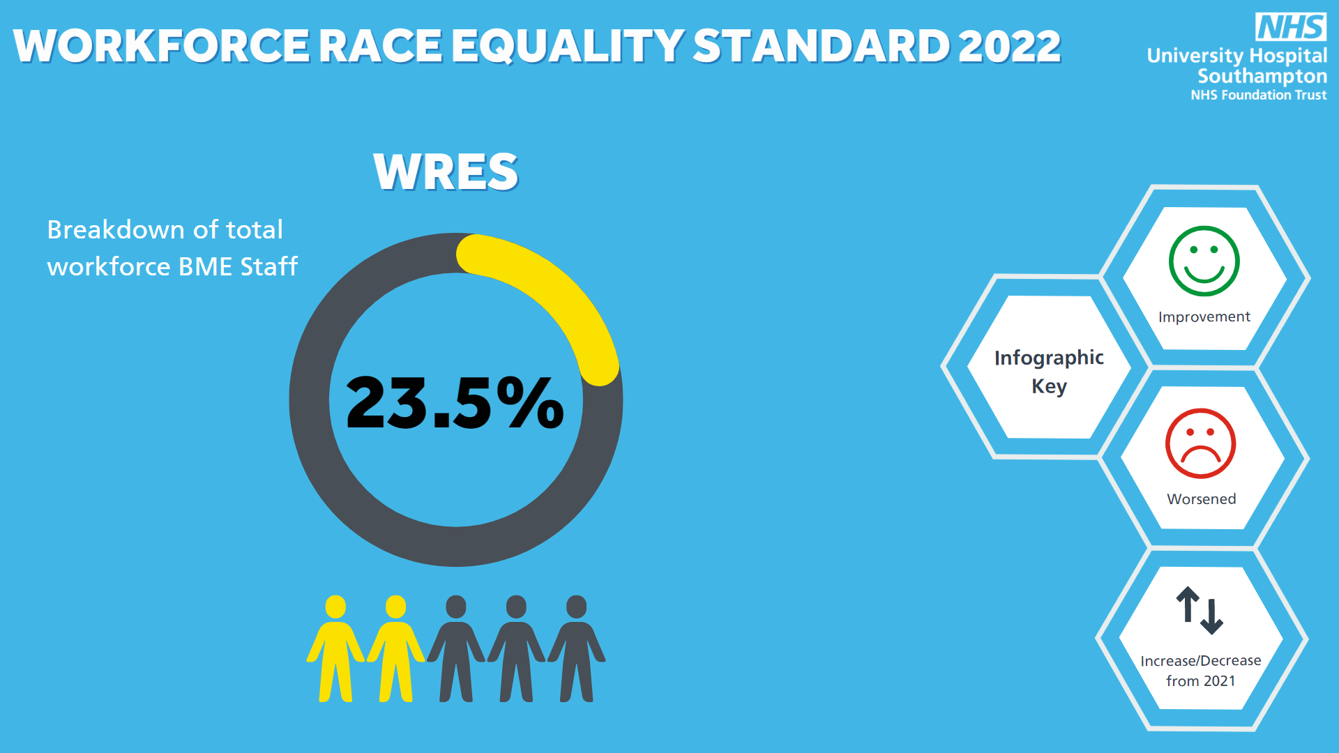
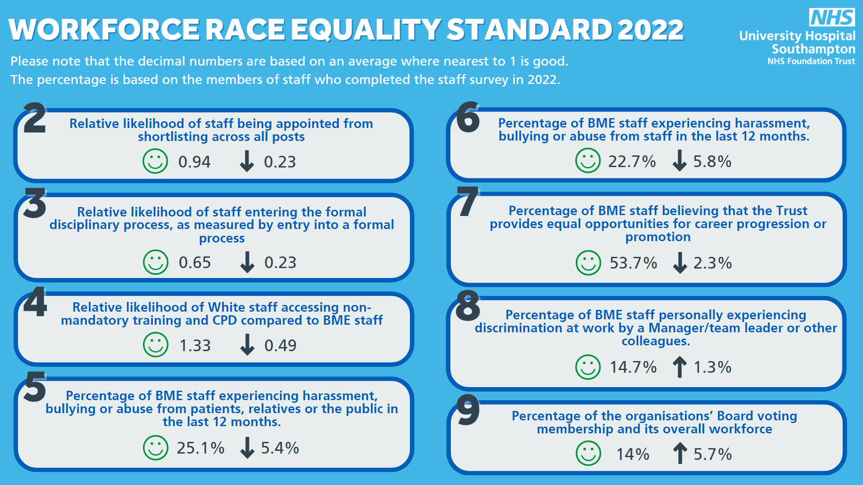

Appendix 2: WRES Action Plan 2022

WRES Themes / Areas | Proposed actions | Responsible for Actions | Deadline / review date
1: Workforce reflecting our communities, at all roles, at all levels; ensuring those who are underrepresented groups can access support to thrive, excel and belong within their roles. | - Achieve 19% BME representation through all levels in both the clinical and non-clinical workforce. This is aligned to National target set and we will remain focused on increasing representation within senior leadership roles within the organisation which currently remain lower in representation of BME staff members. | Chief People Officer / Director of OD & Inclusion | September 2023
 | - To develop and initiate positive Action Programmes both UHS and HIOW system wide; for BME staff and/or other protected characteristics. Acknowledging individuals experience of barriers to promotion, development and career progression. | Workforce Inclusion & Belonging Consultant / Head of EDI / Head of OD | July 2023
 | - UHS partnership with maaha people in developing and running a positive action leadership programme which will enrol 24 individuals who identify with a protected characteristic and will be designed to support individuals looking to move into, or those who are moving through senior leadership roles within the organisation, building on individuals personal identity, power and influence within the organisation. | Workforce Inclusion & Belonging Consultant | January 2023
 | - Partnership with the Florence Nightingale Foundation; Nurse leadership programme aimed at aspiring nurses from backgrounds that are under-represented in our nursing workforce and ensuring that opportunity for individuals is equal and representative of wider society. | Deputy Director of Nursing & Head of OD | April 2023
 | - Talent development programme for individuals supporting the career development, pathways, training and development of individual’s, ensuring talent workstreams and pipelines that encourage opportunity at earlier stages than current and will include long-term career planning. Develop a talent pipeline/talent management plan to include stretch activities, secondments, shadowing, specialist training, qualifications, coaching and mentoring. This will look at strengthening as well as unearthing our current talent within UHS and ensuring that individuals continue to thrive, excel and belong and we support them to do this. | Head of Talent Management / Head of EDI / Workforce Inclusion & Belonging Consultant | July 2023
 | - Continue to build on newly found working relationship with Southampton job centre. Continue to liaise, attend and promote UHS as an employer of choice, the support that is offered and the career opportunities that are available including volunteering roles. | Workforce Inclusion & Belonging Consultant / HR Recruitment team | April 2023
 | - Partnership with Black History Month South to outreach into schools with high BME pupil populations, aiming to positively influence young people from BME backgrounds into NHS careers. | Head of EDI / Workforce Inclusion & Belonging Consultant | June 2023
2: Safe and healthy working environments, free from aggression, hate and discrimination | - Creation of a behaviour framework to bring to live our Trust Values and more clearly describe the expected behaviours relating to equality, diversity and inclusion that impact BME staff and/or those with a protected characteristic. | Director of OD & Inclusion / Head of EDI / Workforce Inclusion & Belonging Consultant | August 2023
 | - Fully establish divisional EDI Steering Groups to drive actions and improvements derived from race specific metrics throughout all teams, care groups and divisions. | Director of OD & Inclusion / Head of EDI | April 2023
 | - Creation of EDI data and information dashboard to evidence improvements and scrutinise themes that impact individuals and determine actions required. | Director of OD & Inclusion / Head of EDI | April 2023
 | - Developing a culture of Allyship: All staff to participate in Actionable Allyship training by 2024. The actionable allyship – stop.Start.continue programme will continue on the statutory and mandatory matrix for all staff to complete. This will provide individuals with the insight, knowledge and skill and to be active allies within a moment of challenging non inclusive behaviours and supporting our statement in becoming an anti-racist and anti-discriminatory organisation. in turn decreasing the disparity of experience between BME and white staff within the organisation. | Workforce Inclusion & Belonging Consultant | August 2023
 | - Continue conversations on race, sharing of lived experience, building on fostering a culture of inclusion where allyship is exampled and individuals feel welcomed, respected, valued and heard to bring their whole and authentic selves to work. | Head of EDI / Workforce Inclusion & Belonging Consultant | August 2023
3: Recruitment processes which are free from bias and are inclusive | - Implement a work programme to review and improve the equity of recruitment processes and practices that impact all individuals. Working group to include partnership with the chairs of the staff network and representation from our diverse workforce. The working group will look at each stage and deliver on recommendations from engagement within the process. Aligning to the NHS People Plan England/Improvement High Impact Actions and Inclusive Recruitment Programme. | Workforce Inclusion & Belonging Consultant | December 2022
 | - Inclusive training, learning and development for all people involved in recruitment and attraction. | Head of Talent attraction / HR Recruitment Team | September 2023
 | - Deliver a truly inclusive process with equitable practices as standard. This will include processes from pre-employment to recruitment, through to employment and the onboarding process. | Head of HR / Head of EDI / Workforce Inclusion & Belonging Consultant | September 2023
4: Inclusive leadership and management | - Inclusive Leadership content in all UHS leadership & management programmes to include personal learning, person action and accountability. This will move us to a place where equality, diversity and inclusion is the golden thread that runs through all our processes at UHS. | Head of OD / Head of Leadership & Development / Head of EDI / Workforce Inclusion & Belonging Consultant | April 2023
 | - Board and Senior leadership programmes to include the element for all leaders plus strategic and cultural responsibilities for equality, diversity and inclusion. | Head of OD / Head of EDI | July 2023
 | - Inclusive leadership and management as part of the UHS Managers Induction Programme. | Head of Leadership & Development / Head of EDI / Workforce Inclusion & Belonging Consultant | April 2023
 | - Implementation of ongoing learning and development opportunities to enable leaders and managers to role model inclusive behaviours every day. For example:  - Inclusive meetings  - Agile working  - Equality impact assessment  - Adjustments required to enable people to thrive and be at their best at work.  - Creating environments for people to succeed  - Support the development of reciprocal mentoring  - Inclusive leadership behaviours aligned to our values | Head of EDI / Workforce Inclusion & Belonging Consultant | September 2023
5: Networks and partnerships that thrive and support creation of an inclusive and safe place to work. | - Development programmes for Networks and Network Chairs clearly identifying roles to enable leadership of highly active networks, clarity of purpose and future plans. | Head of EDI / Workforce Inclusion & Belonging Consultant | May 2023
 | - Heightened focus to re-engage active membership of the one voice network and to support the interim chair in securing a permanent position. Development opportunities will include; coaching, mentoring, influential leadership skills and recognising their contributions as career development opportunities. | Head of EDI / Workforce Inclusion & Belonging Consultant | April 2023
 | - Implement and establish the Equality, Diversity and Inclusion Council; A place for network leads and members alongside the equality, diversity and inclusion team to dialogue with one another, bring forward ideas or concerns from the networks and a place for the voices of all individuals within the organisation to be recognised and heard. This will also offer a place for future projects and funding to be discussed and where a decision on what risks and/or assurances need to be raised within committee meetings. | Director of OD & Inclusion / Head of EDI / Workforce Inclusion & Belonging Consultant | November 2022
 | - Network chairs to remain a standing member and integral voice for diverse individuals at all people committees and board meetings | Chief People Officer / Director of OD & Inclusion | September 2023

