**Aria – EDTA query (Aug 2016)**

The screen is defaulting back to CrCl because the EDTA result had expired and the original regimen was built in Planner as AUC using CrCl. Therefore the result needs to be added as a new “Test” to allow EDTA value to be used for calculation

Select Assessments – Test from top of screen

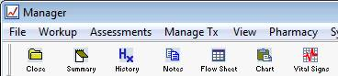

Then New (bottom left of screen)

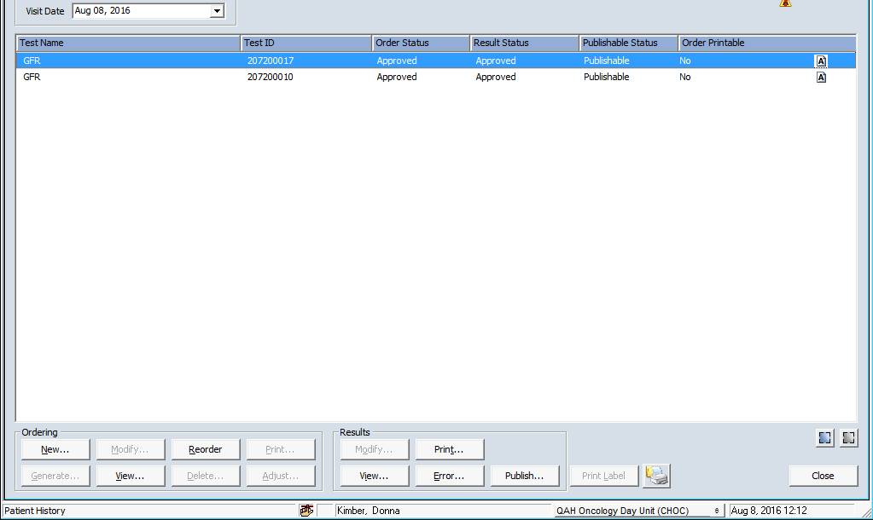

Select CSCCN Lab Req.

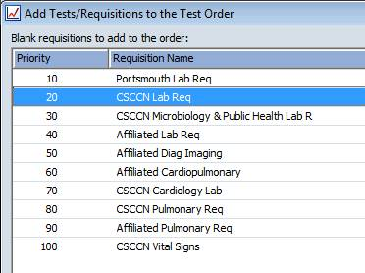

Then tick the required test – EDTA

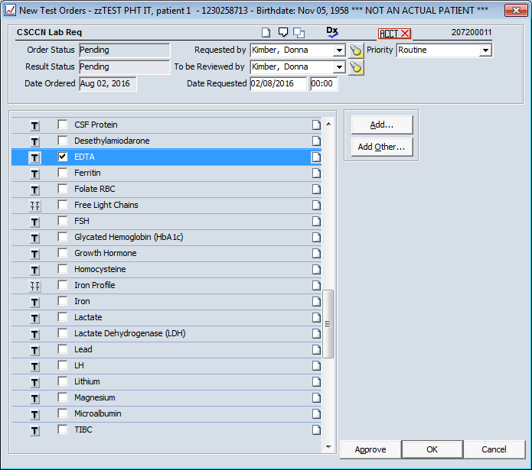

Click – Approve

In Tests window highlight CSCCN Lab Req - Click Modify – from Results box on bottom of the screen

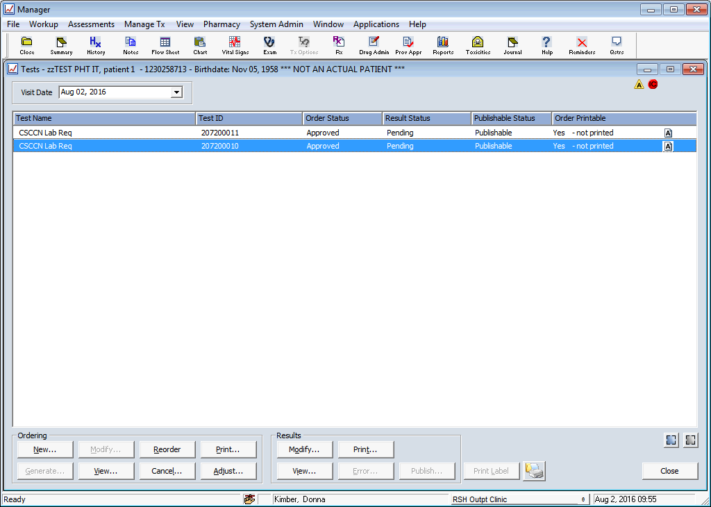

You can then enter the EDTA

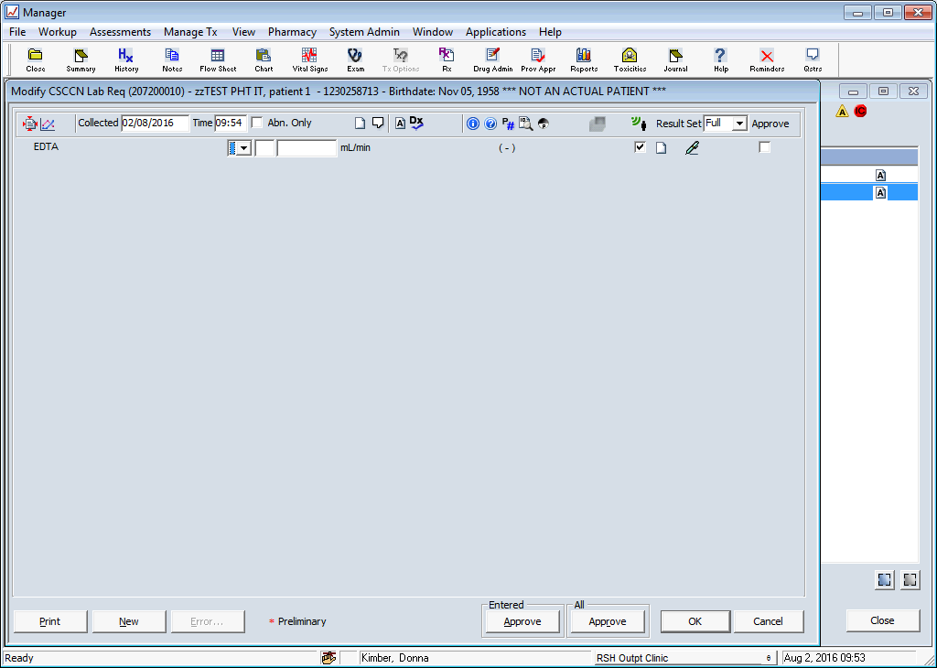

Hope this helps.