ARIA – Discontinue/delaying – using green pen icon (Nov 2018)
The green pen icon on the left of the screen can be used to Modify, Delay or Discontinue a regimen, this button is very sensitive and will only respond if the top left of the icon is clicked, above the pen.
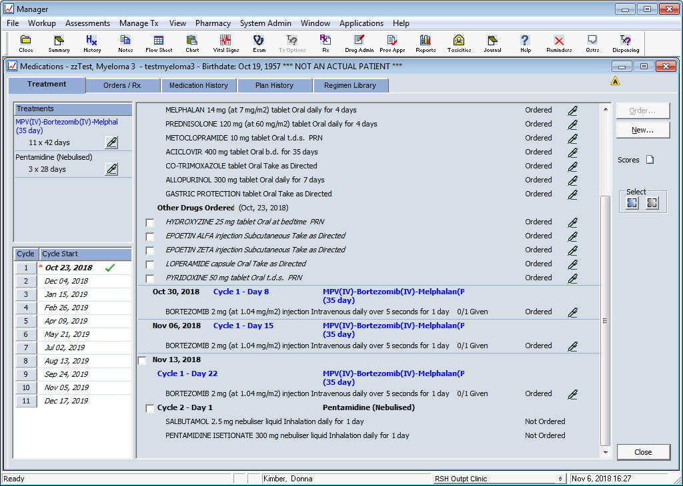
Discontinue – click green pen icon in the left column, under treatment tab. Select Discontinue from drop down menu
A pop up message will appear – click Yes
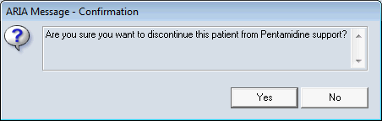
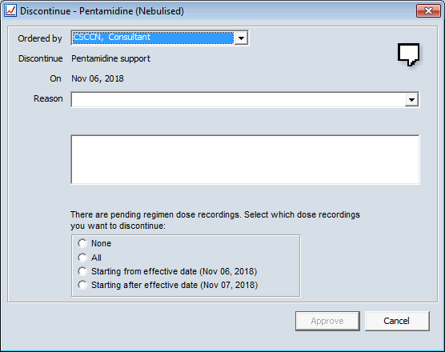
Pending Dose Recordings when discontinuing regimens.
- None
  - Indicates that none of the pending dose recordings will be discontinued and are listed for recording.
  - The regimen is discontinued, but any approved orders, will remain active until dose administration is completed.
- All
  - Indicates that all of the pending dose recordings will be discontinued
  - All Approved orders with pending dose recordings are inactivated.

- Starting from effective date (<effective date>)
  - Indicates that all of the pending dose recordings with administration dates that fall on or after the effective date will be discontinued.
  - All of the pending dose recordings that have administration dates that fall before the effective date are listed for recording.

- Starting after the effective date (<next day's date)
  - Indicates that all of the pending dose recordings with administration dates that fall after the effective date will be discontinued.
  - All of the pending dose recordings that have administration dates that fall before and on the effective date are listed for recording.

In this example I have discontinued All which will remove all of the doses for drug administration
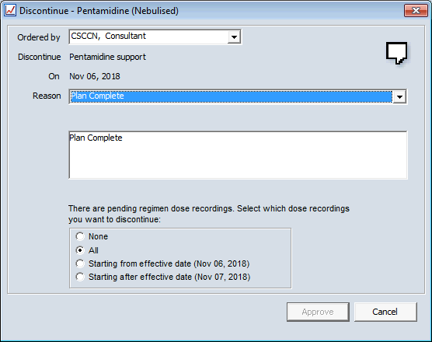
Click Approve – this pop up appears – click OK
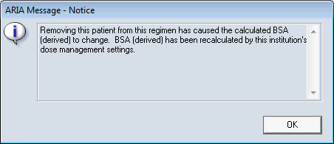
This may take some time depending on how many cycles/doses need to be discontinued, do no click on any other part of the screen, please wait for the process to complete.

Delay a regimen - click green pen icon in the left column, under treatment tab. Select Delay from drop down menu
Enter delay eg 1 week – this will then move all subsequent cycles to be delayed by a week, also enter a reason from the drop down menu.
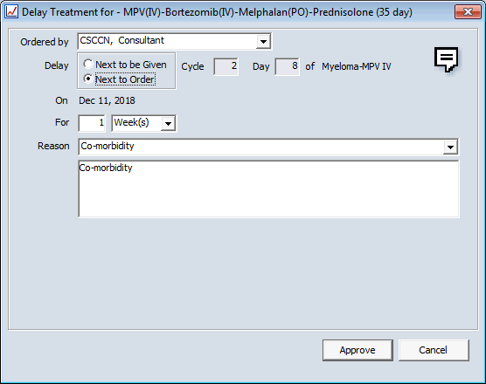

Cycle is delayed by 1 week, a red star appear in the left column next to delayed cycle
