ARIA – Modify (to add/ remove cycles or change cycle length) – using green pen icon (Nov 2018)
Modify - click green pen icon in the left column, under treatment tab. Select Modify from drop down menu
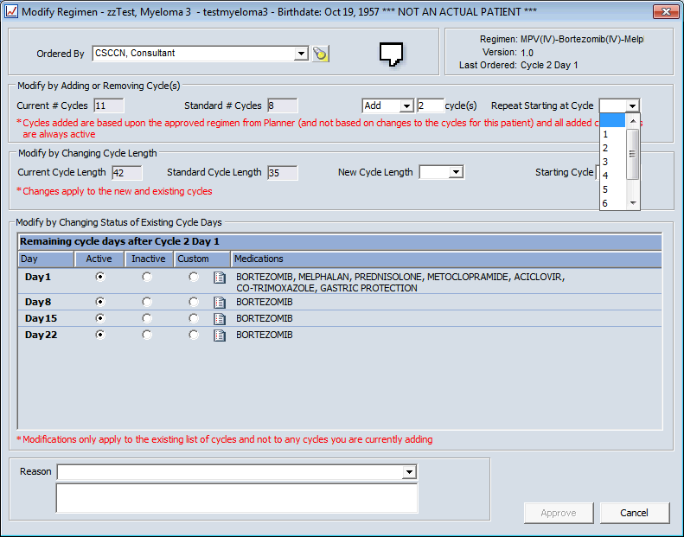
Add / Remove cycle – click drop down arrow to select Add/Remove and enter number of cycles eg 2
Repeat Starting at Cycle – select cycle from drop down menu. NB if different agents/doses are on different cycles ensure you select the correct cycle to start from eg if cycle 1 only is split dose do not select repeat from cycle 1 because it will go back to start at cycle 1, it is usual to select the repeat to start at the last cycle listed in the drop down menu.
New Cycle Length – select number of days from drop down menu or free text, select Starting Cycle (this will usually be the next cycle to order).
You will need to enter a Reason at the bottom of the screen, this can be selected from the drop down menu.
Approve
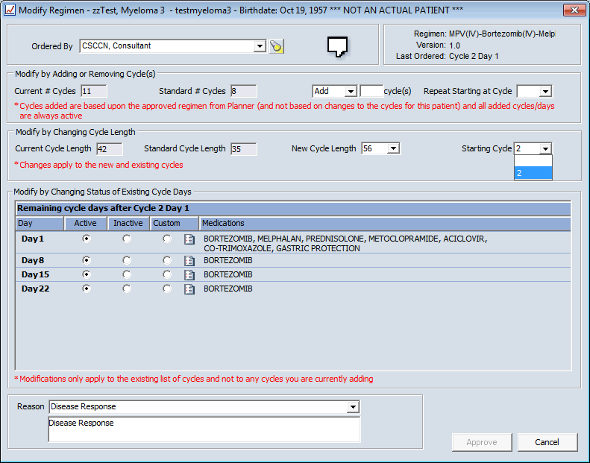
The cycle length has now changed to 56 days
Although cycle length has been amended you will NEED TO AMEND NUMBER OF DAYS REQUIRED FOR TTO (Pick-up Internal) agents using Modify for each agent, this will not change automatically.
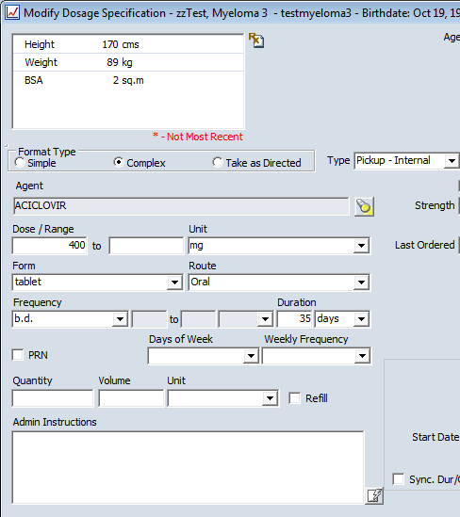
Duration – this will default to the number of days on the original regimen, you need to amend this to the number of days now required for the new cycle length eg 56
Admin Instructions – any test in this box will appear on the printed prescription as directions sent to out-patient pharmacy

