Aria – adding creatinine value

When ordering any regimen with carboplatin this pop up box will appear if
- There is no creatinine value in Aria
- The height and weight was added in Aria after the creatinine value
- The creatinine result in Aria is greater than 10 days old

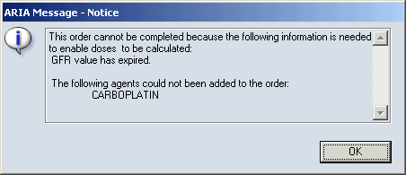
You will therefore need to manually add the creatinine value
Select Assessments (top row of the screen) – then GFR from drop down list
Add the creatinine umol/mL result, then Approve
