BRAMSHAW WOMEN’S UNIT.

STUDENT WORKBOOK

Name:
Team:
Mentor:
Buddy:
Introduction. Welcome to Bramshaw Women’s Unit. We hope that you enjoy your placement here and learn about caring for women and women’s health.
Gynaecology encompasses a wide variety of sub – specialities from early pregnancy, through urogynaecology to gynae-oncology, covering a wide variety of conditions. All women are different and their care should be individualised to respect their needs and the needs to treat the condition that they present with. Caring for women within the field of gynaecology is a demanding speciality.
It is hoped that this workbook will present opportunities for you to broaden your knowledge of gynaecology and research an area that you find of particular interest. It is divided into 3 sections, General gynae, gynae oncology and early pregnancy.

Section 1: General Gynae
Aim: to develop an understanding of some general gynae conditions.
Objectives: 1. Name the female reproductive organs and associated structures
2. Describe the functions of the above structures
3. Identify some common gynae conditions.

The Female Genital Tract.
The female genital tract consists of:
- Vulva
- Vagina
- Cervix
- Uterus
- Fallopian tubes
- Ovaries

Describe the structures of the female reproductive tract and name their function.

- Vulva

- Vagina

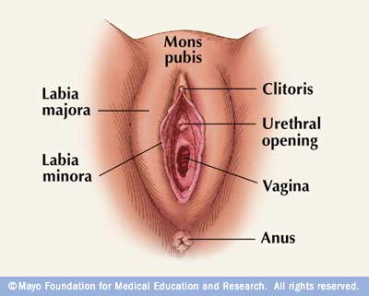

- Cervix

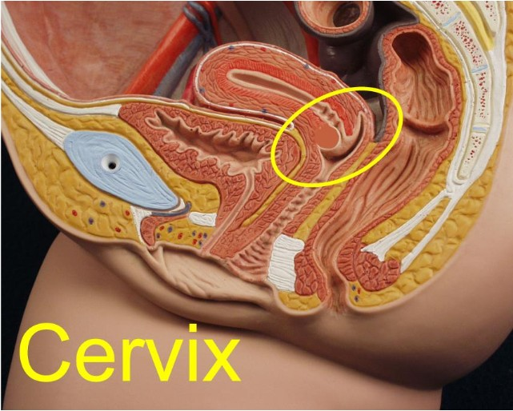
This diagram clearly shows the close proximity of the components of the female reproductive tract and the associated structures.

- Uterus

- Fallopian tubes

- Ovaries

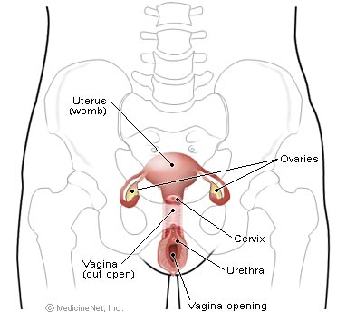

Associated Structures:
Name the structures in close association with the reproductive organs

Common Gynae Problems:
Define the following:

Dysfunctional uterine bleeding:

Menorrhagia –

Metorrhagia –

Polymenorrhoea –

Hypermenorrhoea –

Menometorrhagia –

Amenorrhoea –

Oligomenorrhoea –

Causes:

Endometriosis:
Incidence –
Cause –
Symptoms –

Ovarian Cysts:
Symptoms –

Fibroids:
Risk factors –

Symptoms –

Prolapse:
Incidence –

Grade 1 –
Grade 2 –
Grade 3 –

Symptoms

Urogynaecology:
Urinary incontinence -

Section 2: Introduction to Gynae Oncology
Aim: to develop an understanding of common gynae oncology conditions
Objectives: 1. Identify the main gynae cancers
2.Name the common risk factors associated with these
3. Describe the common treatments

What is Cancer?
This is a generic term used to describe as many as 200 diseases all arising from different tissues causing different illnesses. Each of these cancers has its own characteristics of incidence, spread and survival rates.
Cancer is a disease of the cell, whereby the cells are out of control, losing their ability to differentiate and can infiltrate into other tissue types – which leads to the spread of the disease.

Gynae oncology is a recognised sub-speciality of general gynae nursing.
Gynae cancers are a diverse group of diseases with different natural histories and responses to treatment.
The most common cancers in this group affect the ovaries, cervix or endometrium. Cancers of the vulva, vagina and other cancers of the uterus are relatively rare.

Find out some information about the main gynae cancers:

Ovarian Cancer –
Risk Factors:

Age group affected:

Symptoms:

Spread:

Staging:

Survival Rates:

Treatment:

Endometrial Cancer –
Incidence:

Cause / Risk Factors:

Symptoms:

Staging:

Survival Rate:

Treatment:

Cervical Cancer -
Incidence:

Cause / Risk Factors:

Screening:

Spread:

Symptoms:

Staging:

Treatment:

Vulval Cancer –
Incidence:

Survival Rate:

Symptoms:

Spread:

Treatment:

General Psychological Implications:
Diagnosis of cancer
Potential threat to life
Altered body image
Potential disfigurement
Female identity
Fertility
Sexuality
Sexual function
Section 3: Introduction to problems encountered in early pregnancy
Aim: To develop an appreciation of some common problems encountered by women during early pregnancy.
Objectives: 1. Understand the basic physiology of pregnancy
2. Name some common disorders of pregnancy
3.Identify types of miscarriage
4. Describe hyperemesis gravidarum

The average human pregnancy lasts:
From 1st day of LMP 280 days = 40 weeks = 9 months + 1 week
From conception to delivery 265 days = 38 weeks

Pregnancy is not just the growth of the uterus and contained fetus; it is a state in which changes occur in every system of the mother’s body.
These changes result chiefly from alterations in hormone production, circulation and metabolism.
It explains the symptoms and signs by which we recognise pregnancy and also it explains many minor disturbances for which mothers seek advice.

Endocrine system:
Placenta – active endocrine gland. It secretes HCG, oestrogen, progesterone and human placental lactogen (HPL)

Human Chorionic Gonadotrophin:
Produced by.............

Action..................

Excreted by........

Oestrogen:
Produced by..........

Action..........

Progesterone:
Produced by.........

Action.........

Human Placental Lactogen:
Produced by...........

Action.............

What happens to –

Thyroid gland

Pituitary gland

Adrenal glands

Describe the changes to the reproductive organs:
Uterus:

Cervix:

Vagina:

Ovaries:

Breasts:

Changes to other systems:
Cardiovascular:
Increased blood volume; haemodilution
Cardiac output increases

Respiratory:
Oxygen requirements increase as pregnancy progresses

Renal:
Enlarging uterus compresses the bladder leading to frequency.
Progesterone causes ureters to become dilated and kinked
Slow emptying of ureter and renal pelvis lead to UTI
Blood flow and glomelular filtration rate increase.

GI Tract:
Muscles relax (cardiac sphincter – oesophageal reflux – heartburn)
Constipation
Taste alters – cravings / aversions (pica)
Increased salivation
Swollen gums
Nausea and vomiting

Skin:
Stretched over abdomen – small tears in deeper layers – striae gravidarum
Increase in pigmentation
Increase in sweat gland activity

Musculo-skeletal:
Placental hormones cause softening of ligaments and joints

General Metabolism:
Activity of all body functions increases to meet the growing demands of the fetus and maternal tissues – 2500 calories required

Common Disorders:
Explain the following –
Heartburn

Constipation

Urinary frequency

Pruritus vulvae

Vaginal discharge

Cramp

Varicose Veins

Backache

Fainting

Insomnia

Parasthesia.

Examine the following:
Vomiting:
Incidence –
Cause –
Treatment-

Define hyperemesis gravidarum –

Bleeding in pregnancy:
Any bleeding in pregnancy is worrying and should be investigated to find a cause.
Incidence.......

Miscarriage:
Incidence......

Define the types:
Threatened –
Missed –
Blighted ovum –
Inevitable –
Recurrent –

Causes –

Ectopic Pregnancy:
Incidence:

Risk Factors:

Mortality rate:

Management:

Symptoms:

Gestational trophoblastic disorders:
Incidence:

Risk factors:

Indications:

Treatment:

Never under-estimate the psychological impact on any gynaecological complication from general gynae through urogynae, gynae oncology to early pregnancy. Your support, reassurance and understanding are vital to the care of these women.

