How to access the VLE
- Type into your web browser address bar www.uhs-vle.co.uk
- Once loaded type your username and password in the Log in fields.
- Click on the Log in button
- You may be prompted to change your password.
- Once you are logged in for the first time you will be shown a user tour. Click ‘Next’ to be shown through the tour stages.
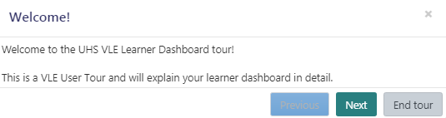

You will see all of your statutory and mandatory training, please click onto “Corporate Induction” and then “Doctors Induction” to complete the induction videos which are vital as an introduction.
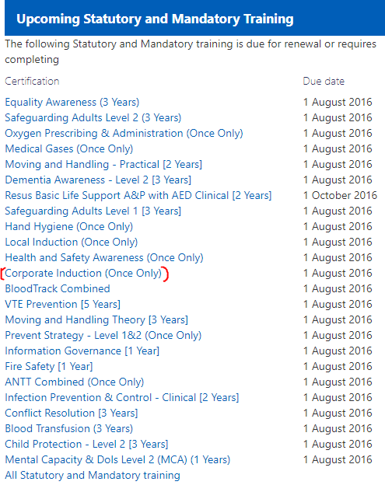

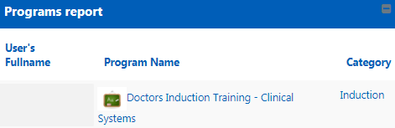
Back at the home page “My Learning Dashboard” you will have been assigned “Doctors Induction Training – Clinical Systems” under Programs report. Click Doctors Induction Training - Clinical Systems.
This program displays four clinical system courses you may need to complete in order to gain access to the relevant clinical system, please see below for more information.
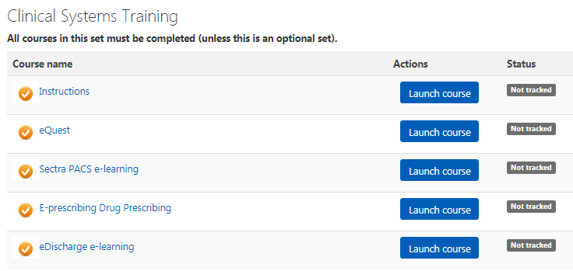

Launch the clinical system training you need for your role (i.e., if you will not need access to the clinical system then there is no need to complete it)

If you have previously worked within the Trust and accessed the clinical systems, you will be required to re-do the training if you have been inactive on the systems for more than 6 months.

Clinical System Training completion will be sent to IT in order to get your Login Details for the system these will be sent to your Trust email ready for you.

Statutory and mandatory training will also need to be completed which can be found under: Upcoming Statutory and Mandatory training.

For questions and queries on induction day please call extension 5500.

